Employee Handbook

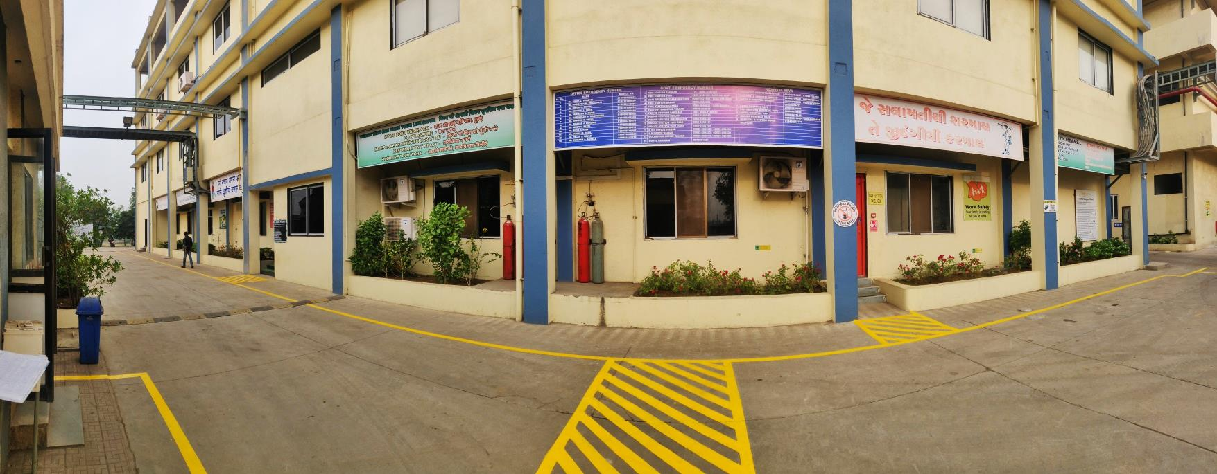



Office: Kohinoor Square, 4401, B Wing, N.C. Kelkar Marg, Opp. Shivsena Bhavan, Dadar (West),
Mumbai – 400028, India
Tel. No: +91-22-35016300-310

Factory: Plot No. – 2201, Road No. 21,
GIDC, Sarigam, Ta. – Umbergaon,
Dist. – Valsad, Gujarat.
Tel.: +91 9978609858
Website: www.valorganics.com
E-mail: info@valorganics.com
Table of Contents
Sr. No. |  | Title | Page No.
1. |  | Table of Contents | 02
2. |  | Introduction | 04
3. |  | Corporate Code of Conduct | 05
4. |  | Policies | 10
 | i. | Health, Safety & Environment Policy | 10
 | ii. | Energy Policy | 11
 | iii. | Water Management Policy | 12
 | iv. | Waste Management Policy | 13
 | v. | Customer Health and Safety Policy | 14
 | vi. | Quality Policy | 15
 | vii. | Anti-Discrimination, Anti-Harassment and Equal Opportunity Policy | 16
 | viii. | CSR Policy | 18
 | ix. | Sustainable Procurement Policy | 19
 | x. | Whistle Blower Policy and Guidelines | 20
5. |  | General guidelines by VAL | 21
6. |  | General responsibilities of Employee | 21
7. |  | General Emergency Information | 22
8. |  | Information, instruction and training | 25
9. |  | Environment | 26
 | i. | Energy Consumption | 26
 | ii. | Water Consumption | 27
 | iii. | Local Pollution | 27
 | iv. | Labelling, Handling & Storing of Chemicals and Waste | 28
 | v. | Waste Management | 28
 | vi. | Sustainable Consumption | 29
10. |  | Health | 30
 | i. | FIRST AID | 30
 | ii. | Pre-Medical Check Up | 30
 | iii. | Regular Medical Check Up | 31
 | iv. | Customer Health and Safety | 31
 | v. | Reporting Hazards | 32
 | vi. | Workplace Inspections | 32
11. |  | Safety | 33
 | i. | Work Place Hazards | 33
 | ii. | Permit Systems | 38
 | iii. | Hazard Identification & Risk Assessment Systems | 43
12. |  | Labour & Human Rights | 51
 | i. | Working Conditions | 51
 | ii. | Insurance & Economic Benefits | 58
 | iii. | Employee Conduct | 62
 | iv. | Labour Relations | 65
 | v. | Child and Forced Labour | 66
 | vi. | Career Management | 67
 | vii. | Harassment, Discrimination & Equal Opportunity | 70
 | viii. | Diversity, Equity & Inclusion | 71
 | ix. | Affinity groups for minorities/vulnerable groups | 72
 | x. | Women's development programs | 73
 | xi. | Work Performance | 74
 | xii. | Workplace Etiquette | 75
 | xiii. | External Stakeholder Human Rights | 76
13. |  | Ethics | 78
 | i. | Corruption & Bribery | 78
 | ii. | Conflict of Interest | 79
 | iii. | Fraud | 80
 | iv. | Money laundering | 80
 | v. | Information Security | 81
 | vi. | Anti-Competitive Practices | 82
 | vii. | Ending Employment | 83
 | viii. | Grievance/ Complaint | 84
14. |  | Sustainable Procurement | 86
 | i. | Ethically Driven | 86
 | ii. | Social Focused | 87
 | iii. | Green Inspired | 88
 | iv. | Quality Centered | 90
15. |  | Revision History | 92
16. |  | Acknowledgement of Receipt | 93

INTRODUCTION

We are glad to have you as a member of Val. As a team member at Val, you are an essential part of a team effort. We hope that you will find your position with the Company rewarding, challenging and productive. Every Employee has an important role in our operations and we Value the ability and experience you bring with you to the organization. You, and other Employees, are vital to the success of Val. We think that Employees are happier and more valuable if they know what they can expect from Val and what the Val expects from them.
Val Organics Pvt. Ltd. is a professional and safety conscious organisation which Values the effective management of health, safety, environment & welfare of employee throughout all stages. In this handbook we introduce you to the Company’s policies, practices, privileges, benefits, and responsibilities of being an Employee at Val. We expect you to incorporate that information into your day-to-day job performance, striving to meet Val’s Values in everything you do.
Please understand that this handbook can only highlight and summarize Val’s policies and procedures. For detailed information, please talk to your respective Plant head or Human Resource department. In this Company, as anywhere, circumstances are constantly changing. As a result, we may have to revise, rescind, or supplement these policies from time to time. Nothing in this handbook is a contract or a promise. The policies can change at any time, for any reason, without advanced notice.
Finally, we hope that this employee handbook will help enhancing your knowledge regarding Health, Safety, Environment & Welfare of Employee.

Corporate Code of Conduct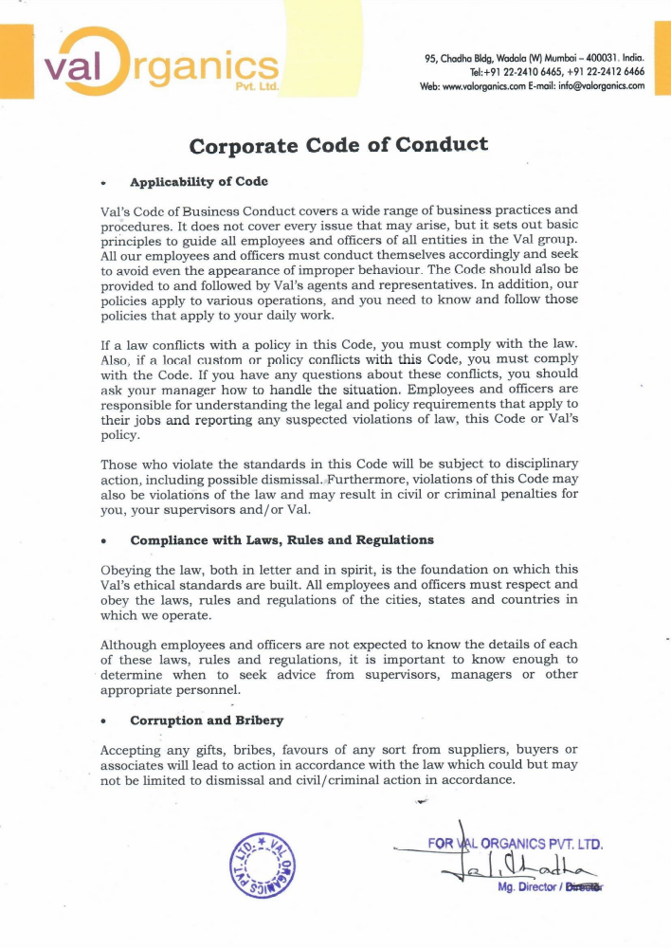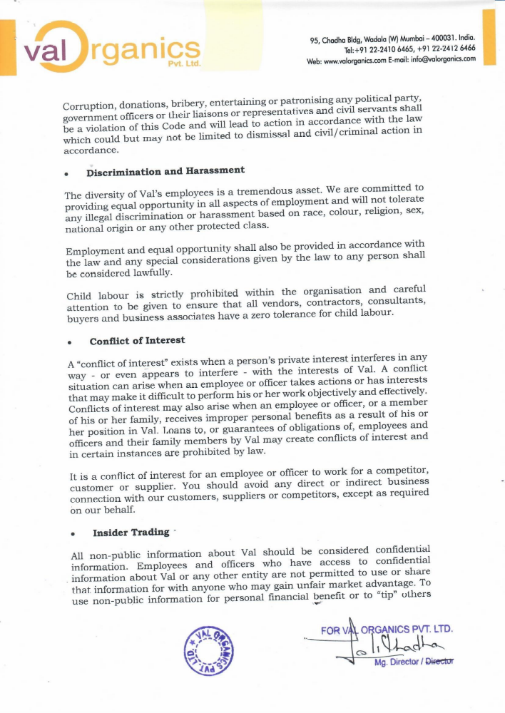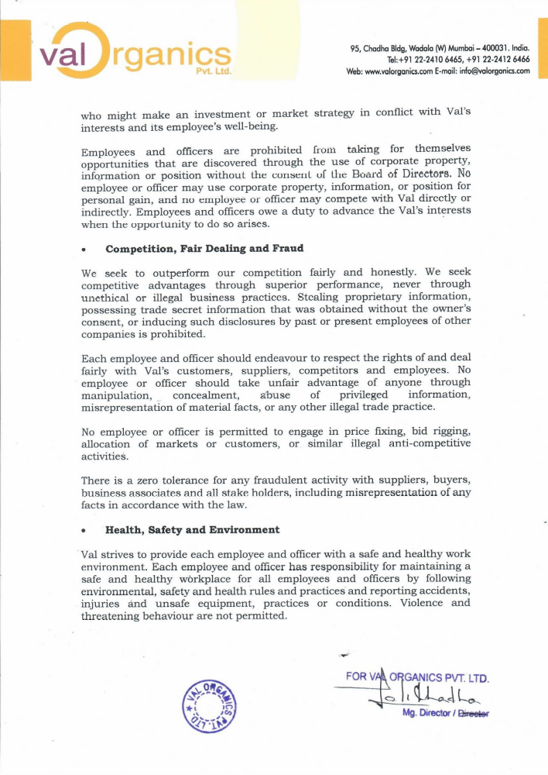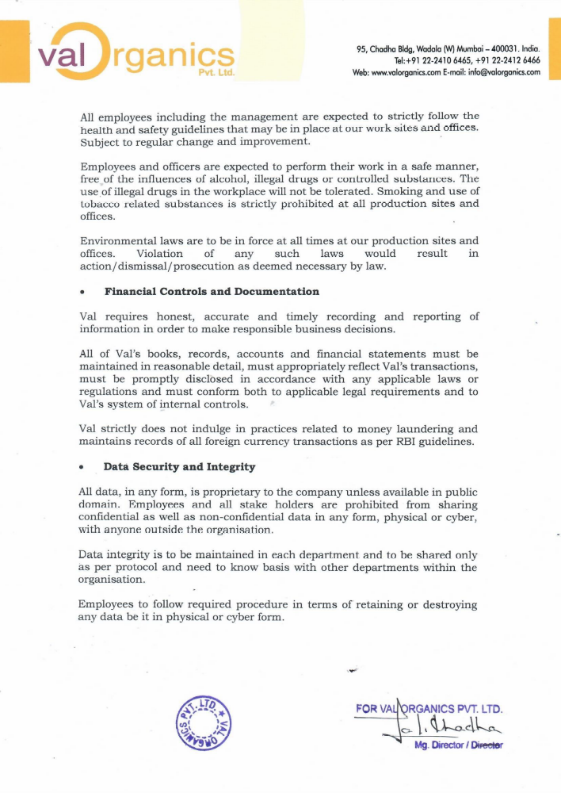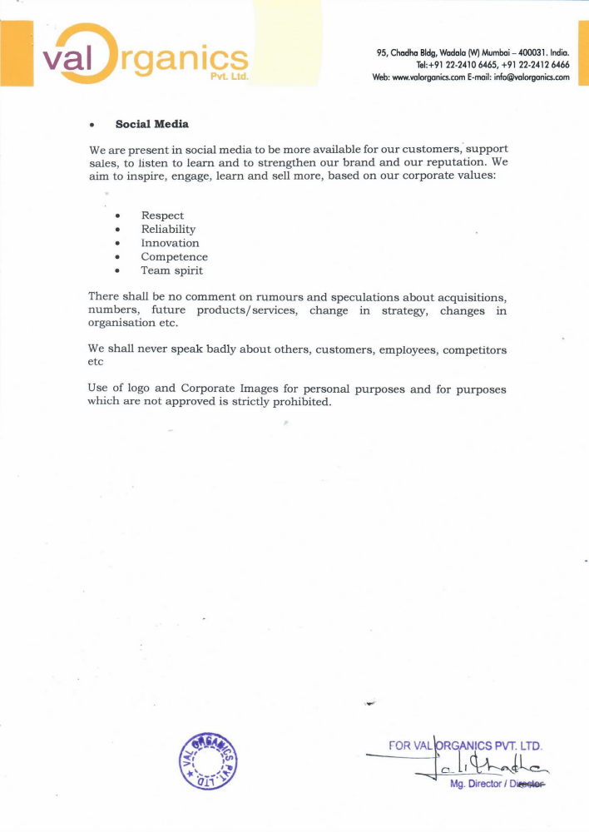

Policies

Health, Safety & Environment Policy
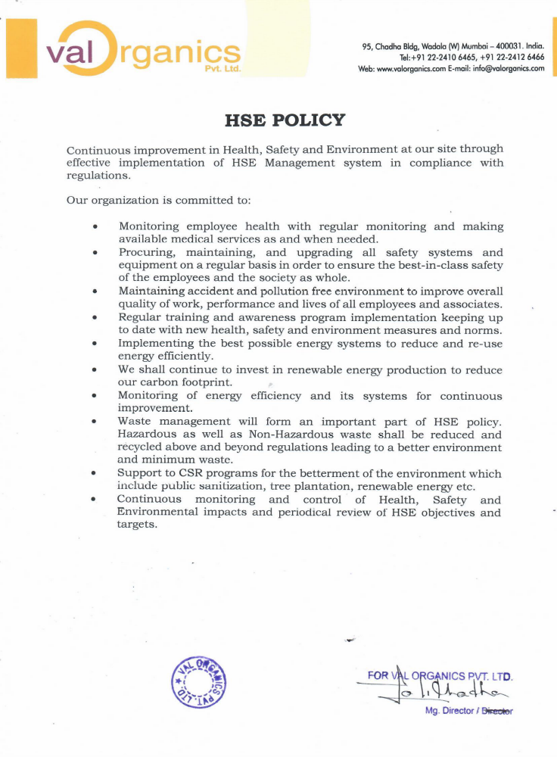

Energy Policy

Water Management Policy

Waste Management Policy

Customer Health and Safety Policy

Quality Policy

Anti-Discrimination, Anti-Harassment and Equal Opportunity Policy

CSR Policy

Sustainable Procurement Policy

Whistle Blower Policy and Guidelines
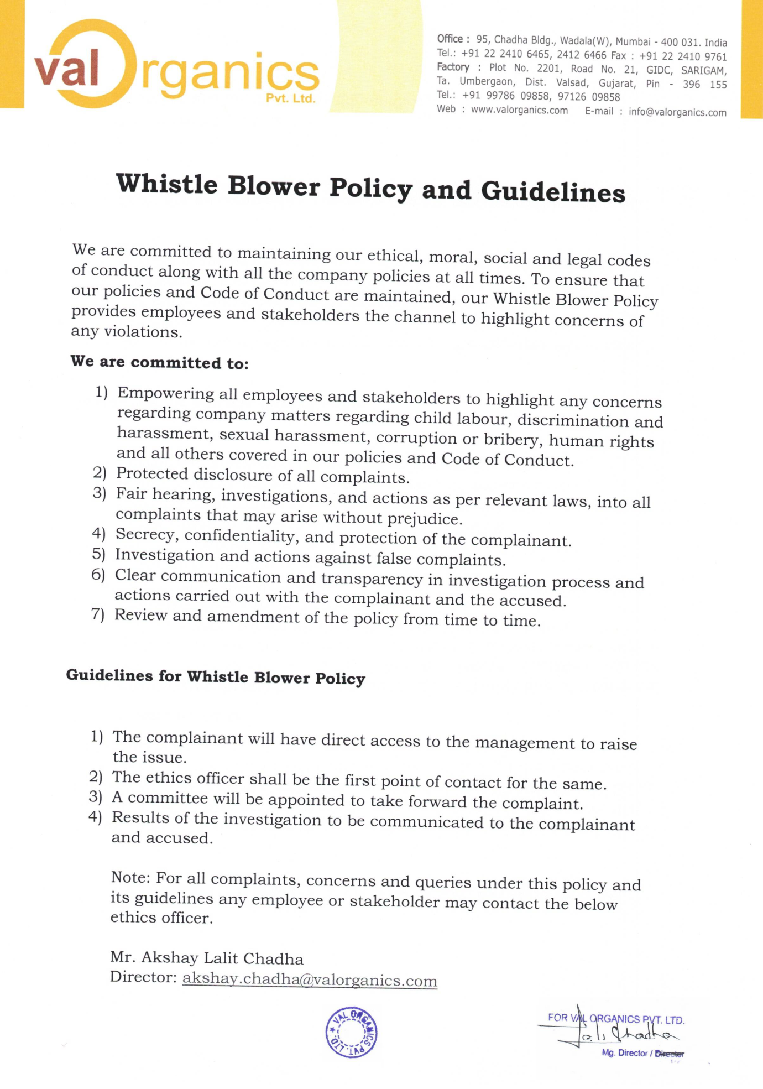
General guidelines by Val
- Employees are required to work in an injury free manner displaying accepted levels of behaviour, avoid behaviours which jeopardize health, safety or security.
- Any conduct that places the employee or others at risk, or which threatens or intimidates others, is forbidden. These are considered serious misconduct and will normally result in disciplinary action, which may include immediate termination.
- Do not enter unauthorised areas.
- Maintenance or civil work should be carried out through required permit system.
- Employee should carry out their work according to Standard Operating Procedure.
- Employee while carrying operation should carry out each step to maintain safe & clean environment.
- Only undertake tasks for which you have been trained.
- Maintain all aisles, exits and vehicle traffic routes clear at all times.
- Maintain all exits unlocked at all times.
- Use and/or possession of illegal drugs or alcohol in company is forbidden.
- Smoking in company is forbidden.
- Use of Mobile phone within the company premises is banned.

General responsibilities of Employee
- To read, understand and comply with Val’s Health, Safety and Environment policy, energy policy, water management policy, waste management policy, customer health & safety policy, safe work practices, safe job procedures and rules.
- As an employee of Val you have a legal duty to take reasonable care of yourself and others and to co-operate with the management on all aspects of health, safety & environment.
- Employee must not interfere with or misuse anything that's been provided for health or safety of employee.
- Employee must be aware of all emergency arrangements.
- Employee must report all incidents, near misses or damage to equipment and property.
- To intervene when witnessing unsafe acts or conditions.
- Employee must carry out your tasks in a safe manner following the Standard Operating Procedure.
- You have a duty to ensure that any personal protective equipment provided for your protection is worn, maintained and stored in the correct manner as directed.

General Emergency Information

Overview
Val Organics Pvt. Ltd has developed an Emergency Preparedness program so that we are ready for an unexpected disaster, whether it’s a natural or man-made one. Our first priority will always be life safety which includes evacuation & contingency plan.

Preparation
Employees must attend training, become familiar with the Emergency Plan, and actively participate in emergency drills, treating them as if they are real.
Chemical Emergencies
Always be ready for an emergency:
- Know the location of the nearest emergency and first aid equipment, including eye washes, emergency showers, fire alarms and fire extinguishers.
- Be aware of those employees in your workplace or nearby who have special emergency training or skills.
- Know the nearest paging call stations and the paging call station number - #777 for help.
- Be able to tell emergency personnel the exact name of the chemical involved.
Unconsciousness
Call #777 through paging call station for help or press the manual call point. Before entering an area to help an unconscious person, make sure that you will not be in danger from hazardous fumes or inadequate oxygen. Respirators and lifelines may be needed but should only be used by individuals previously trained. If you are able to enter the area remove the victim to fresh air immediately. Provide adequate first aid by first aider while waiting for medical personnel. If the victim’s eyes or skin are contaminated, flush with running water. Remove any contaminated clothing.
Fumes
If you work with chemicals, be aware of warning symptoms of overexposure to hazardous fumes. Get fresh air immediately if you sense a burning of irritation in your nose, throat, or lungs; have difficulty breathing; feel weak, dizzy or nauseous; or notice a strong odour. Close the source if possible. If these measures don’t help, leave the area & checking all the person are evacuated & plant is in safe mode.

Eye Contact
Flush your eye immediately with running water. Use an emergency shower or eye wash station. Hold your eyelids apart and roll your eyeballs. Do not use ointments or salves, which may be dangerous. Continue flushing for at least 15 minutes. Get immediate medical attention.
Skin Contact
Drench your clothing and skin thoroughly with plenty of water. Use emergency shower. Remove contaminated clothing while drenching it and continue to flush skin with water for at least 15 minutes. Get medical attention.
Evacuation Emergencies
If you hear the alarm or discover an emergency such as a fire, explosion, gas leak, chemical spill, or a violent situation:
- Remain calm

- Press the nearest manual call point

- If possible, declare the severity & type of incident on paging call station.

- Incident controller in co-ordination with site main controller will declare the kind of emergency.

- If the incident is controllable, he will give the specific information to site controller & no need to raise the siren.

- If the emergency needs help from other department he will tell site controller to raise the siren.

- As the siren is raised bring the plant to safe mode.

- Make sure the area is clear of people.

- Assist anyone who requires assistance, if required.

- Leave the building via the nearest exit, do not use an elevator.

- Go to the assembly area.

- Notify everyone in the area of the assembly point.

- Types of siren

- If the emergency is fire siren will blow for one minute with 10 seconds up & 10 seconds down.
- If the emergency is gas leakage siren will blow for one minute with 20 seconds up & 20 seconds down.
- All clear siren will blow continuously for 60 seconds.

- Site Main controller is only authorised to call outside agencies in case of Off-Site emergency.

- Emergency information of contact numbers in case of Off-Site emergency.

- Police Station – 100

- Fire Station –101

- Ambulance – 108
Roles of Team in Val
All the employees of Val are classified into four teams.
- First Aid Team

- Fire Fighting Team

- Spill Control Team

- Rescue Team

- If the emergency is Fire, Fire extinguishers & Fire Hydrant are located throughout the facility and are available to help you evacuate. You are not responsible for extinguishing the fire – focus on your safety. Fire Fighting team along with the fire fighting head is deployed to tackle emergency created through the fire. Based on the help he requires fire fighting head will call the required team.

- If the emergency is spill/leak, keep away from it unless you know what it is and how to clean it up safely. Don’t try to deal with any large spills of hazardous material yourself & get help. If solvents are involved, remove sources of ignition. Spill Control team along with Fire Fighting team with their respective head is deployed to tackle emergency created through the spill. Based on the help he requires spill control head will call the required team.

- Rescue team will be responsible to rescue the people trapped in emergency.

- First Aider team is responsible to first aid the injured person.

Information, Instruction and Training
Overview
Protecting Environment, Preventing accidents and ill health caused by work is a key priority. Health, Safety & Environment information, instruction and training helps the company to ensure that employees are not injured or made ill or harm environment by the work they do; promotes a positive Health, Safety & Environment culture.
Inspection
Training records inspections is carried out through Internal Audit.
Employee Responsibilities
- All heads of department are responsible to schedule & provide training at regular interval of time.
- All employees should co-operate with the company in relation to all training aspects.
- All employees should follow training, guidance and instruction to prevent injury or ill health.

Environment
It is critical to protect the environment so as to reduce the destruction of eco-systems. It is more of a moral obligation for humans to protect the environment from pollution and other activities that lead to environmental degradation. Importantly, environmental degradation is detrimental since it threatens the long-term health of the animals, humans and plants.
It is everyone’s responsibility to take care of the environment to make this planet a wonderful place to live.

Energy Consumption

Overview
Reducing energy consumption limits the number of carbon emissions in the environment which play a significant role in climate change. Reduced emissions result in cleaner air quality & help sustain the resources we already have.

Inspections
Workplace inspections are carried out through Internal Audit for the reduction in energy consumption & finding solutions for energy reduction.

Employee Responsibilities
- HSE head is responsible for introducing and maintaining cost-effective ways of providing management information about energy consumption.
- HSE head is responsible to provide training to employees through which we can save or reduce the consumption of energy.
- HSE head is responsible for raising and maintaining energy awareness throughout organisation.
- All employees working in plant are responsible to report the source of energy wastage.
- All employees working in plant are free to provide any suggestion or techniques reducing energy consumption.
- Employee performing the job must follow the correct procedures in accordance with the VOPL/HSE/010: SOP of Waste Management.

Water Consumption

Overview
Reducing water consumption usages reduces the energy required to process and deliver & energy required to treat the waste water which in turn, helps to reduce pollution and conserve fuel resources.

Inspections
Workplace inspections are carried out through Internal Audit for the reduction in water consumption & finding solutions for reduction in water consumption.

Employee Responsibilities
- HSE head is responsible in introducing and maintaining cost-effective ways of providing management information about water consumption.
- HSE head is responsible to provide training to employees through which we can save or reduce the consumption of water.
- HSE head is responsible for raising and maintaining water awareness throughout organisation.
- All employees working in plant are free to report the source of water wastage.
- All employees working in plant are free to provide any suggestion or techniques reducing water consumption.

Local Pollution

Overview
Air pollution, water pollution, soil pollution & noise pollution are the impacts from company operations on local environment around company facilities through the emissions of dust, noise, odour, accidental pollution and road congestion.

Inspections
Report & Workplace inspections are carried out through Internal Audit for the management & monitoring of environment pollution.

Employee Responsibilities
- Factory Manager, HSE Head & Plant Incharge are responsible for ensuring their company’s compliance with the procedure.
- Area Incharge/ HSE Head is responsible for providing training.
- Employee performing the job must follow the correct procedures in accordance with the VOPL/HSE/030: SOP of Management & Monitoring of Environmental Pollution.
- HSE Personnel is responsible for the monitoring of pollution.
- Quality Control department personnel are responsible for the analysis of effluent water.
- Maintenance head is responsible for the preventive maintenance of pollution control equipment.

Labelling, Handling & Storing of Chemicals and Waste

Overview
Raw materials, chemicals, non-hazardous and hazardous waste generated from operations is necessary as when improperly labelled, handled or stored, can cause substantial harm to human health, safety or to the environment.

Inspections
Workplace inspections are carried out through Internal Audit for the labelling, Handling & Storage of Chemical & Waste.

Employee Responsibilities
- HSE Head & Area Incharge are responsible for ensuring their company’s compliance with this procedure.
- Area Incharge/ HSE Head is responsible for providing training.
- Employee performing the job must follow the correct procedures in accordance with the VOPL/HSE/027: SOP of Labelling, Handling & Storing of Hazardous Materials.

Waste Management

Overview

Waste management is very necessary in the present day context for the following reasons: To prevent pollution of the environment and its natural resources like air, water and land; To prevent complete exhaustion of the resources like minerals, water, etc.; To produce energy which could be an alternative for the fast depleting fossil fuels and other conventional sources of energy; To make optimum use of the waste generated; For a better and sustainable future.

Inspections
Waste reduction team is deployed for the management of waste & find solution for waste minimization & reduction.

Employee Responsibilities
- HSE Head is responsible for providing training to the employee & working with staff to keep this policy up to date.
- Waste reduction team is responsible to work accordingly to VOPL/HSE/010: SOP of Waste Management.
- Every employee is responsible to co-ordinate with waste reduction team for the reduction of waste.
- Every employee is responsible to work accordingly to VOPL/HSE/010: SOP of Waste Management.

Sustainable Consumption

Overview

Sustainable consumption is the practice of using resources and products in a way that minimizes environmental and social impacts, while meeting human needs and well-being. It is a key component of sustainable development, which aims to balance economic, social and environmental goals.

Inspections
Points raised in Internal Audit for sustainable consumption are added in HSE objectives & follow-up taken by HSE department.

Employee Responsibilities
- HSE Head is responsible for providing training to the employee & working with staff to encourage them for promoting sustainable consumption.
- Every employee is responsible for using sustainable consumption at the best from his end.
- Every employee is responsible for giving sustainable consumption options to HSE head.
- HSE head is responsible to discuss the sustainable consumption options came from employee side for sustainable consumption in Internal Audit meeting and to add valid points in HSE objectives.

Health
Everyone must encourage a healthier workforce as promoting employee health is beneficial for both employee & employers. It creates a positive and efficient work culture and environment. This will further support a healthy work environment and create a work-life balance. A healthier workforce is more engaged, focused, and productive. Being healthy improves the overall quality of life, reducing risk factors for diseases & contributes heavily to an employee’s overall engagement within the business.

FIRST AID

Overview
First aid is the care given to an injured worker before professional medical help arrives. First aid may mean the difference between life and death. The purpose of this section is to preserve life, prevent any injuries from getting worse, and to help injured worker recover.

Inspections
First Aid box & other medical things related to first aid are checked through the inspections carried out in Internal Audit.

Employee Responsibilities
- HSE Head/Factory appointed Doctor is responsible to provide training to first aider of plant.
- First Aider of particular area is responsible to maintain first aid box fully stocked.
- First Aider is responsible to first aid the injured person.
- First Aider is responsible to log the first aid case with the injury/disease description & description of First Aid provided.

Pre-Medical Check Up

Overview
Pre-employment check-ups are a means to establish baseline health data against which the future health status of the employee can be compared. It is also a means of identifying existing medical conditions, which can help to protect the employee if there is any risk associated with the occupational exposure.

Inspections
Records of Pre-medical check-up of new joining are checked through the inspections carried out in Internal Audit.

Employee Responsibilities
- Human resource Head is responsible to carry out pre-medical check-up of new joining.
- Human resource head is responsible to check whether the employee is fit or unfit according to the medical report & will take the action according to VOPL/HR/007: SOP of Pre-medical check-up.

Regular Medical Check Up

Overview
Regular medical check-up helps your employee to keep a track on their health status and thus take precautionary steps at the right time.

Inspections
Records of Regular medical check-up of all employees are checked through the inspections carried out in Internal Audit.

Employee Responsibilities
- Human resource Head is responsible to schedule regular medical check-up of employee after every six month.
- Factory appointed doctor is responsible to visit the site every Saturday.
- All the employees are responsible for their half yearly medical check-up.
- Any employee can discuss their health related issue to factory doctor on his visit on Saturday.

Customer Health and Safety

Overview
We ensure our customers health & safety by keeping our global supply chain intact safer by ensuring all HSEQ standards maintained at its most at our site.

Inspections
The systems in the organization can be continuously assessed, monitored & improve with the help of Internal Audit.

Employee Responsibilities
- Factory Manager is responsible for sharing major changes to customers as mentioned in the VOPL/QA/019: SOP of Customer Health & Safety.
- All employees are responsible to follow VOPL/QA/019: SOP of Customer Health & Safety for standard, safer processing techniques and practices which ensure continuous supply and quality products.

Reporting Hazards

Overview
A hazard is something that has the potential to cause harm, ill health or injury during the course of the work activity.

Employee Responsibilities
- It is the duty of all employees to report hazards to their HSE head immediately.
- HSE head is responsible to assess the situation and introduce the necessary control measures, so far as is reasonably practicable, to prevent injury or unsafe conditions.
- It is the duty of head of particular department to whom the responsibility is given by HSE head to introduce necessary control measures.

Workplace Inspections

Overview
Workplace inspections are the primary mechanism for recognition, assessment, and control of hazards in the workplace. By working together, we can manage workplace hazards and support a healthy and safe work environment.

Inspections
Workplace inspections is carried out through Internal Audit.

Employee Responsibilities
- Employee must cooperate with any inspections and let the HSE personnel know of any hazards you are aware of.
- Supervisor is responsible to identify and control hazards, as part of their regular duties.

Safety
Safety of employees refers to the provision of a safe working environment, safe equipment, policies, and procedures in order to ensure worker’s safety.
Safety in the workplace has a significant impact in business KPIs. In other words, safer working environments benefit from fewer accidents, which results in fewer occupational health costs, better employee retention and satisfaction, less employee downtime, and less retraining time.

Work Place Hazards

Ergonomics

Overview
Injuries of the muscles, nerves, tendons, ligaments, joints, cartilage, spinal discs, blood vessels or related soft tissue including a sprain, strain and inflammation. Ergonomics hazards occur when the job, or the way it is done, does not fit the worker's physical capabilities, and the worker uses their body to adjust to difficult or awkward situations.

Inspections
Workplace inspections is carried out through Internal Audit.

Employee Responsibilities
- Use the equipment provided in the correct manner
- Follow proper safe operating procedures, work practices and lifting techniques
- Try to eliminate the need for lifting and carrying by using, carts, conveyors and pallet jacks.
- Report hazards, defective equipment, stressors and ergonomics symptoms to your supervisor.

Noise

Overview
Noise induced hearing loss is very common. It is permanent and irreversible. Usually, it is caused by long-term exposure to excessive noise from machines and equipment generating high noise.

Inspections
Workplace inspections is carried out through Internal Audit.

Employee Responsibilities
- Follow the instructions on any posted signs, wear and use the personal protective equipment provided.
- Employee is responsible to report any concern related to noise to HSE head.

Contact with Machinery

Overview
Machines often are running at high speeds and can exert substantial forces. Hazards such as sprockets, pulleys, gears or belts can instantaneously entangle or draw in body parts or clothing causing severe injuries or even death.

Inspections
Workplace inspections is carried out through Internal Audit.

Employee Responsibilities
- Do not bypass or remove any safeguarding from machines or equipment without authorization.
- Report hazards, defective equipment and missing or damaged safeguarding to your Plant Incharge/Supervisor.
- Plant Head is responsible to maintain proper safeguarding over the machinery.

Slips, Trips and Falls

Overview
The majority of the falls are on the same level namely slips and trips due to debris, spills, loose tiles, wet or unclean floors, obstructions that interfere with the traffic flow, people running or engaging in horseplay.

Employee Responsibilities
- Every employee must be proactive in maintaining a clean workplace to help prevent slips, trips and falls.
- It is the duty of employee to fill housekeeping checklist in a particular area in which he is working.
- Head of Plant Incharge is responsible for ensuring whether his plant is maintained with good housekeeping.
- All the personnel involved in the housekeeping will work accordingly to VOPL/HSE/017: SOP of Housekeeping.
- HSE Head is responsible for providing training.

Lighting

Overview
Providing adequate lighting levels to enable personnel to work is a basic necessity. Good lighting that considers physiological and psychological needs of employees will create a work environment that is welcoming, energising and productive.

Inspections
Workplace inspections is carried out through Internal Audit.

Employee responsibilities
- Employee should report any defective lighting to the electrical department through work order.
- Employee should report any discomfort experienced as a consequence of lighting in the workplace.
- Electrical head is responsible for the preventive maintenance of emergency lights.

Electrical Safety

Overview
The electrical safety standard requires the adoption and implementation of safe installation and work practices to prevent electrical shock, electrocution, and arc flash/blast.

Inspections
Workplace inspections is carried out through Internal Audit.

Employee Responsibilities
- Report all electrical problems and suspected problems to your supervisor.
- Electrical personnel are only responsible for the maintenance of electrical equipment.
- Inspect all plugs, cords, and portable equipment prior to use.
- Never stretch extension cords across aisles or areas where others may trip over them.
- All electrical panels must remain closed.
- Follow all procedures related to electrical maintenance & work according to the VOPL/HSE/009: SOP of Electrical Safety.

Static Electricity

Overview
Static electricity is generated by the contact and separation of materials, and clearly this generation often cannot be prevented in the industry. We must therefore aim at control measures.

Inspection
Workplace inspections is carried out through Internal Audit.

Employee Responsibilities
- It is the responsibility of Electrical head for proper bonding & earthing of every equipment in the plant.
- It is the responsibility of Electrical head for maintaining proper resistance Value in earth pit.
- It is the responsibility of Maintenance & Plant Head to check the static grounding clamp on the pipe & earthing and bonding of the equipment after maintenance.
- It is the responsibility of the employee handling, loading or unloading liquid from one container/equipment to another to prevent the build-up of static electricity and prevent sparks from causing a fire, by bonding & earthing dispensing and receiving containers/equipment together before pouring.

Preventive Maintenance

Overview
Defective tools and equipment are a hazard that can cause serious injury or incidents. The regular maintenance of tools, equipment, and vehicles will maximize the safety of all employees and protect property.

Inspection
Preventive maintenance document & Workplace inspections is carried out through Internal Audit.

Employee Responsibilities
- It is the responsibility of Maintenance Head to ensure preventative maintenance to any tool, equipment or vehicle requiring scheduled maintenance or calibration follow the manufacturer’s recommendations, industry standards, and is performed by qualified personnel.
- The personnel performing the preventive maintenance is responsible for maintenance & will ensure maintenance is performed as scheduled and is recorded.
- Follow all procedures related to preventive maintenance according to the VOPL/ME/017: SOP of Maintenance of equipment.

Permit Systems

Maintenance or Civil Work

Overview
Work Order Cum Permit is required before carrying out any kind of maintenance or civil work. The objectives of the Work Order Cum Permit System are to exercise control over the maintenance, repair and construction activities by assigning responsibilities, ensuring clear cut communication between interested functions & safety considerations to the job, its hazards & the precautions required.

Inspections
Workplace inspections is carried out by Issuing & Requiring department through Work Order Cum Permit.

Employee Responsibilities
- HSE Head is responsible for providing training.
- Only those employees who have completed six month & have attempted the written competency evaluation test and passed are responsible to involve in the Work Order Cum Permit.
- All the employees are responsible to carry out any kind of maintenance or civil work through Work Order Cum Permit (Do not Bypass Work Order).
- All the employees are responsible not to allow carrying out any hot, height, civil, excavation and confined space / vessel entry work based on Work Order Cum Permit.
- Head of department, Production engineer, supervisor, lab chemist and production operator are authorized for issuing work order permit to maintenance department against any kind of maintenance or civil work.
- Head of Maintenance, Maintenance Engineer and Project Engineer are authorized for accepting WOCP from issuing department against any kind of maintenance work.

Height Work

Overview
Work at height means work in any place where, if there were no precautions in place, a person could fall a distance liable to cause personal injury.

Inspections
Workplace inspections is carried out by Issuing, Requiring & HSE department through Height work permit.

Employee Responsibilities
- HSE Head is responsible for providing training.
- Only those employees who have completed six month & have attempted the written competency evaluation test and passed are responsible to involve in the Height Work.
- All workers involved in height work permit must be trained to perform height work duties.
- Plant supervisor is responsible for the evaluation of job & filling the height work permit.
- Plant supervisor/Incharge is responsible for the providing information regarding hazards involved in the work to the personnel who is going to perform the work.
- Plant Incharge is responsible for the evaluation of job, filling the height work permit & approving the height work permit by signing in permit issuing authority.
- Maintenance Engineer/ Incharge is responsible for the evaluation of job, appropriate PPE wore by the personnel carrying out work & approving the height work permit by signing in permit requiring authority.
- HSE head is responsible for the evaluation of job, identifying hazards, appropriate PPE wore by the personnel carrying out work & give instruction personnel to do the work in proper and safe manner.
- After all safety precautions & controlling measures found in place HSE head will approve the height permit by signing in safety officer.
- It is the responsibility of all company employees to stop the work carried out on height without Height work permit.
- All the personnel’s involved in the height work will work accordingly to VOPL/HSE/020: SOP of Height Work.

Hot Work

Overview
A hot work is work involving open flame, producing hot surfaces, or generating sparks or molten material of sufficient energy to work as an ignition source leading to fire or explosion.

Inspections
Workplace inspections is carried out by Issuing, Requiring & HSE department through Hot work permit.

Employee Responsibilities
- HSE Head is responsible for providing training.
- Only those employees who have completed six month & have attempted the written competency evaluation test and passed are responsible to involve in the Hot Permit.
- All workers involved in hot work permit must be trained to perform their hot work duties.
- Plant supervisor is responsible for the evaluation of job & filling the hot work permit in issuing section.
- Plant supervisor/Incharge is responsible for the providing information regarding hazards involved in the work to the personnel who is going to perform the work.
- Plant Incharge is responsible for the evaluation of job, filling the hot work permit & approving the hot work permit by signing in permit issuing authority.
- Maintenance Engineer/Incharge is responsible for the evaluation of job, a filling the hot work permit in requiring section & approving the hot work permit by signing in permit requiring authority.
- HSE head is responsible for the evaluation of job, identifying hazards, appropriate PPE wore by the personnel carrying out work & and gives proper instruction to both the standby persons about the hazard and activity to look after and also give instruction to personnel to do the work in proper and safe manner.
- After all safety precautions & controlling measures found in place HSE head will approve the hot work permit by signing in safety officer.
- It is the responsibility of all company employees to stop the hot work carried out without hot work permit.
- All the personnel involved in the hot work will work accordingly to VOPL/HSE/021: SOP of Hot Work.

Confined Space Entry

Overview
A confined space entry is work involving in confined space having potential for personal injury, death or death resulting from the hazard of confined space.

Inspections
Workplace inspections is carried out by Issuing, Requiring & HSE department through Confined space entry permit, Rescue plan for confined space entry & Blinding and person record entry for confined space entry.

Employee Responsibilities
- HSE Head is responsible for providing training.
- Only those employees who have completed six month & have attempted the written competency evaluation test and passed are responsible to involve in the Confined Space Entry Permit.
- All workers involved in confined space entries must be trained to perform their confined space entry duties.
- Plant supervisor is responsible for the evaluation of job & filling the confined space entry permit in issuing section.
- Plant supervisor/Incharge is responsible for providing information regarding hazards involved in the work to the personnel who is going to perform the work.
- Plant Incharge is responsible for the evaluation of job, filling the confined space entry permit & approving the confined space entry permit by signing in permit issuing authority.
- Maintenance Engineer/Incharge is responsible for the evaluation of job, filling the confined space entry permit in requiring section & approving the confined space entry permit by signing in permit requiring authority.
- HSE head is responsible for the evaluation of job, identifying hazards, appropriate PPE wore by the personnel carrying out work & and gives proper instruction to both the standby persons about the hazard and activity to look after and also give instruction to personnel to do the work in proper and safe manner.
- After all safety precautions & controlling measures found in place HSE head will approve the confined space entry work permit by signing in safety officer.
- It is the responsibility of all company employees to stop the confined space entry carried out without the confined space entry permit.
- All the personnel involved in the confined space entry will work accordingly to VOPL/HSE/022: SOP of Confined Space Entry.

LOTO (Lock Out Tag Out)

Overview
Lockout/Tagout (LOTO) are the practices and procedures necessary to de-energize, control and secure all hazardous forms of energy for machinery or equipment. The purpose of LOTO is to prevent the release of hazardous energy while employees perform any tasks where there is a risk of exposure to hazardous energy.

Inspections
Workplace inspections is carried out by Issuing, Requiring & HSE department through LOTO permit.

Employee Responsibilities
- HSE head is responsible for providing training.
- Only those employees who have completed six month & have attempted the written competency evaluation test and passed are responsible to involve in the LOTO Permit.
- All workers involved in LOTO permit must be trained to perform their LOTO duties.
- Plant supervisor/Incharge is responsible to try by with the physical check and verification & filling the try by name & signature.
- Maintenance Engineer/Incharge is responsible for filling the LOTO permit in Engineering Department.
- Electrical Engineer is responsible for filling the LOTO permit in Electrical Department.
- It is the responsibility of all company employees to stop the work without the LOTO permit where LOTO is applicable.
- All the personnel involved in the LOTO will work accordingly to VOPL/HSE/024: SOP of LOTO.

Hazard Identification & Risk Assessment Systems

Risk Assessments

Overview
The process of risk assessment is to reduce the risk of injury & ill health and identify:
- The significant hazards that employees may be exposed to.
- Who could be harmed and how.
- Identifying existing control measures.
- The likelihood of someone being harmed by the hazard.
- What (if any) further actions are required.
- Appropriate Safe Systems of Work and necessary training.

Inspections
HIRA, HAZOP, JSA and many more risk assessment methods are checked through the inspections carried out in Internal Audit.

Employee Responsibilities
- HSE Head is responsible for risk assessment of all the potential risk of hazards with the capacity to cause a disaster.
- Every employee is responsible to co-ordinate with HSE team for the risk assessment of the hazards.
- Every employee is responsible not to carry out any work without risk assessment.

Incident Investigation Report

Overview
Investigating a worksite incident a fatality, injury, illness, or close call- provides employers and workers the opportunity to identify hazards in their operations and shortcomings in their safety and health programs. Most importantly, it enables employers and workers to identify and implement the corrective actions necessary to prevent future incidents.

Inspection
Inspection will be carried out through Incident Report form & Incident Investigation form.

Employee Responsibilities
- All employees are responsible to report all incidents and major near misses, including ergonomic issues to HSE head within the reporting timeline.
- Plant supervisor in co-ordination with eye witness is responsible to fill the Incident Report form.
- Plant Incharge is responsible to verify the form.
- HSE head is responsible to receive form.
- Investigation Team is responsible to investigate the Incident.
- Investigation team is responsible to follow the VOPL/HSE/006: SOP of Incident Report & Investigation while investigating the incident.
- HSE head is responsible to close the incident investigation report after finding proper root cause & eliminating the hazard.

Hazard & Operability Analysis (HAZOP)

Overview
A hazard and operability study (HAZOP) is a structured and systematic examination of a complex planned or existing process or operation in order to identify and evaluate problems that may represent risks to personnel or equipment

Inspection
Workplace & Record inspections is carried out through Internal Audit.

Employee Responsibilities
- Factory Manager/HSE head is responsible to implement HAZOP for particular process.
- Heads of all departments are responsible to participate in HAZOP study.
- Employee from particular section are responsible to participate in HAZOP study.
- Head of particular department is responsible to comply the recommendation raised in HAZOP.

Hazard Identification & Risk Assessment (HIRA)

Overview
Hazard Identification and Risk Assessment (HIRA) in Safety provides you with a deep understanding of hazards and risk associated with every process, sub-process and activities.

Inspection
Workplace & Record inspections is carried out through Internal Audit.

Employee Responsibilities
- Factory Manager/HSE head is responsible to implement HIRA for particular process.
- Heads of all departments are responsible to participate in HIRA.
- Employee from particular section are responsible to participate in HIRA.
- Head of particular department is responsible to comply the recommendation raised in HIRA.

Management of Change (MOC)

Overview
Management of Change (MOC) is a best practice that controls safety, health, and environmental risks and hazards as they pertain to an organization’s changes to its facilities, operations, or personnel.

Inspection
Workplace inspections is carried out through Management of Change Form.

Employee Responsibilities
- Head of respective department is responsible to initiate MOC if any change is going to happen in his premises.
- Factory manager is responsible to approve the change for initial review.
- Head of HSE department is responsible to review HSE aspects of proposed change, recommend against any findings/concerns, and observe the change till its post implementation review.
- Head of production, technical, engineering, quality assurance and quality control department are responsible to review the proposed change against their different concerns and to recommend & are also responsible for pre and post implementation review of proposed change.
- Head of different department are responsible to attain the concerns raised of their scope while assessing the proposed change.
- Technical director is responsible for final approval and authorization of change.

Pre-Start-up Safety Review (PSSR)

Overview
The PSSR is a systematic and thorough check of a process which includes construction and equipment are in accordance with design specifications, safety, operating, maintenance, and emergency procedures are in place and are adequate; A process hazard analysis has been performed for new facilities and recommendations have been resolved or implemented before startup, and modified facilities meet the management of change requirements; and training of each employee involved in operating a process has been completed.

Inspection
Workplace inspections is carried out through Pre Start up Safety Review Checklist.

Employee Responsibilities
- Head of department, Project & Process Engineer are responsible to implement PSSR for particular process.

Controlling Hazards

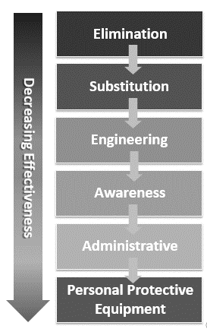
Overview
A control is a method used to mitigate (or manage) the risk associated with a hazard or potential hazard. There are several methods to control hazards and they differ in their effectiveness. The best control is one that eliminates the hazard completely. It is best to start at the top of the list and only move down the list when the current method is not feasible.
Since this is not always possible, we may need to look for ways to reduce the risk to an acceptable level.

Inspection
Workplace inspections is carried out through Internal Audit for Controlling Hazards.

Employee Responsibilities
- It is the responsibility of employee to report any hazards they are aware of to their supervisor.
- Workers must cooperate with the supervisor to identify controls that would reduce the risk of the hazard.

Hazard Information Labels
Our industry use systems originally developed by the National Fire Protection Association (NFPA) & Globally harmonized System (GHS) to label the relative hazard of materials.
Hazard Information Labels - NFPA
The systems use a combination of colours and numbers to rate the hazard of a material in a way that is easily interpreted. The original NFPA system is arranged as four squares mounted inside a larger square on point. The system provides information on the health, flammability, instability/physical hazard, and special hazard/personal protection of materials and indicates the severity of each hazard by use of a numerical ranking of 0 (no hazard) to 4 (extreme hazard).

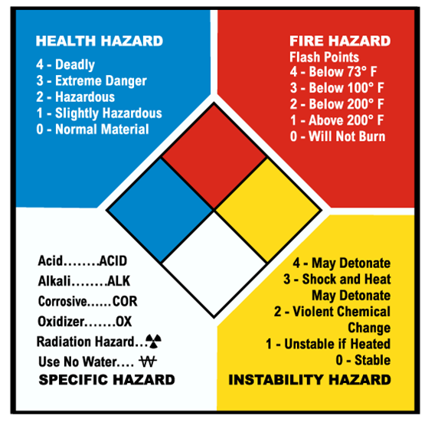

Hazard Information Labels – GHS
GHS defines and classifies the hazards of chemical products, and communicates health and safety information on labels and safety data sheets
Key Terms in GHS vocabulary
- SDS – Safety Data Sheet. SDS is the term used by GHS for Material Safety Data Sheet (MSDS).
- Hazard group – While not given a formal definition, GHS divides hazards into three major groups – health, physical and environmental.
- Class – Class is the term used to describe the different types of hazards. Category – Category is the name used to describe the sub-sections of classes.
- Hazard Statement – For each category of a class, a standardized statement is used to describe the hazard.
- Precautionary Statement – These statements are standardized phrases that describe the recommended steps to be taken to minimize or prevent adverse effects from exposure to or resulting from improper handling or storage of a hazardous product.
- Signal word – There are two signal words used by the GHS – Danger and Warning. These signal words are used to communicate the level of hazard on both the label and the SDS.
- The GHS uses a total of nine pictograms as shown below:

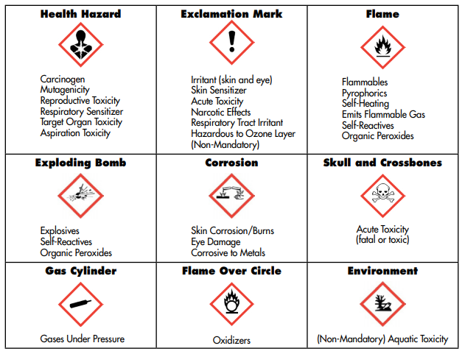

Personal Protective Equipment

Overview
Personal protective equipment (PPE) is the last line of defence to protect workers. The best way to manage hazards in the workplace is to find ways to eliminate them. Sometimes the use of personal protective equipment becomes the only option to protect workers from those hazards and to prevent injury or illness.

Employee Responsibilities
- It is the responsibility of employees to use & maintain PPE as prescribed in the VOPL/HSE/001: SOP of Usage of PPE.
- HSE Head is responsible for the inspection of PPE.
- Employee is responsible to requisite PPE in the place of old PPE.
- Store personnel is responsible to issue new PPE in place of old PPE.

Safety Footwear |   All employees are required to wear steel toed safety boots in the premises of company.

Gloves |   Employees exposed to chemicals or engaged in a work activity that has the potential to damage the hands, fingers or wrists must wear the proper gloves to prevent this type of injury.  Do not wear gloves around machinery which has rotating sprockets, belts or shafts.  Gloves will increase the chance of being pulled into the machine.

Safety Eyewear |   Employees engaged in a work activity that has the potential to damage the eyes must wear approved safety glasses, goggles, and/or face shield to prevent injury.

Hearing Protection |   All employees that work in a noisy environment with sound levels at or above 75 decibels are required to wear hearing protection.

Head Protection |   Hard hats must be worn where there is a risk of head injury. Hard hats need to be fitted they should not be too loose or too tight as that can hinder their effectiveness.
Welding and Hot Work |   Employees performing welding or hot work must wear the required PPE appropriate for the task.  - Welding helmet, hand shield, goggles    - Insulated gloves  - Rubber-soled safety boots

Respirators |   Anyone working in the breathing space of an airborne toxic dust, gas, vapour, smoke or fume must wear a NIOSH approved respirator. The type of respirator will depend on the type of toxic chemical. Make sure to check that it’s the correct one for your situation and that it fits properly. If your respirator uses cartridges, make sure to check that it’s the correct type one for your situation. Respirators must be worn when handling or using any chemical where the SDS states that a respirator is required, or where the airborne concentrations are above the exposure limit. Employees required to use respirators will be fully trained on how to use them.

Industrial Hygiene |   - Always wash your hands and any exposed skin that might have come in contact with chemicals or biological hazards. See the MSDS for specific instructions.  - Protective clothing or other safety devices that have been worn next to the skin will be cleaned and disinfected prior to being worn by another worker.  - PPE should be stored in a manner to maintain cleanliness and good condition.

PPE Replacement | - Maintain your PPE: Clean it and store it properly  - If PPE gets damaged or ineffective, bring it to the supervisor’s attention and immediately remove it from use.

Labour & Human Rights
Human rights reflect the minimum standards necessary for people to live with dignity, freedom, equality, justice, and peace. Human rights give people the freedom to choose how they live, how they express themselves & among many other things. Human rights also guarantee people the means necessary to satisfy their basic needs, such as food, housing, and education, so they can take full advantage of all opportunities. Finally, by guaranteeing life, liberty, equality, and security, human rights protect people against abuse by those who are more powerful.
Labour right improves the working conditions of the workers. Labour rights improves industrial relation between employee & employer, protect worker from exploitation by the employer or management, helps worker in getting fair wages, minimize labour unrest, ensure job security, promotes favourable environment condition, fixes work hour, provide compensation to worker & many more.
With Labour & human rights company can create a productive work environment that elevates business growth.
Working Conditions

Working Hours

Overview
The normal work week in Val Organics Pvt. Ltd. consist of six (6) days & eight (8) hours for shift personnel and eight & half (8.5) hours for general shift personnel & will vary with employee based on their week off. Work hours are different for different shifts. Four shifts are run in Val. Work hours for First shift is 7:00 to 15:00, Second shift is 15:00 to 23:00, Night shift is 23:00 to 7:00 & General shift is 10:00 to 18:30, including half hour for lunch. All the management personnel will work in general shift. Head of employee will allocate the shift to employee that best suits the need of the work through shift schedule for the month.

Employee Responsibilities
- Helpers, Operators & Supervisor is responsible to report for any kind working conditions i.e. wages, overtime, or working hours to their respective head i.e. Plant Head.
- Plant Head is responsible to report for any working conditions i.e. wages, overtime, or working hours to their head i.e. Factory Manager.
- Factory Manager is responsible to report for any kind of working conditions i.e. wages, overtime, or working hours to their head i.e. Factory Director.

Wages

Overview
The Val’s wages guidelines are designed to provide you with a salary that is competitive with local and national market conditions. All positions are classified under specific titles and salary grades or ranges. Wages increases occur within minimum to maximum ranges assigned to each job classification.

Employee Responsibilities
- Management personnel are responsible to decide the appropriate wages to the employees.
- Human Resource head is responsible to input accurate information of wages into the computerized business system.

Extra hours working benefits

Overview
When operating requirements or other needs cannot be met during regular working hours, Employees may be scheduled to work overtime. When possible, advance notification of these assignments will be provided. All overtime work must be authorized in advance by their head. The Company will attempt to distribute overtime evenly. The Company provides compensation for all overtime hours worked by employees in accordance with his/her salary. Overtime will be paid for 1.5 times the regular hourly rate for hours worked beyond the standard 40-hour workweek. Employees will be expected to work the hours documented in their offer letter at time of hire. Any hours worked in excess without their heads approval may result in disciplinary action.

Employee Responsibility
Human resource head is responsible to provide extra hours working benefits to employee.

Salary Administration

Overview
Salary is distributed in all employees account in between date 5 & 7, except when either of those days falls on a Saturday, Sunday or holiday, in which case salary will be distributed on the preceding workday. All salary deductions are itemized and presented to employees with the salary slip. Approved salary deductions will include: professional taxes & provident fund.

Employee Responsibility
Human Resource head is responsible for the administration of salary.

Worker’s Compensation

Overview
If employee suffers a work-related injury or illness while working in the company, Val provides employees benefits to replace lost income and to compensate for certain permanent losses to the body. Compensation benefits include a return-to-work program to help employees resume productive activity. It is important to report a work-related injury as soon as possible. Human Resource department will help you with this process. Other than this Val offer compensation for the following components.
Compensation Components

The remuneration package consists of the following elements:

- Base Salary: A fixed regular pay rate corresponding to the assigned job classification.
- Shift Differentials: Supplementary pay premiums for working specific shifts, such as nights or weekends.
- Performance-Based Pay: Implementation of incentive programs to reward surpassing performance targets, such as productivity bonuses or safety incentives.
- Overtime Pay: Compensation for employees exceeding their scheduled hours at an overtime rate, as dictated by relevant laws and regulations.
- Benefits: Provision of a comprehensive benefits package, encompassing health insurance, paid time off (PTO), and retirement plans (specifics detailed in a separate benefits manual).

Compensation Component | Description | Details/Examples
Base Salary | A fixed regular pay rate corresponding to the assigned job classification. | Determined by job title and experience level.
Shift Differentials | Supplementary pay premiums for working specific shifts, such as nights or weekends. | Additional 20% for night shifts, 15% for weekend shifts.
Performance-Based Pay | Implementation of incentive programs to reward surpassing performance targets. | Productivity bonuses up to 10% of base pay; safety incentives include annual bonuses for zero workplace accidents.
Overtime Pay | Compensation for employees exceeding their scheduled hours at an overtime rate. | 1.5 times the regular hourly rate for hours worked beyond the standard 40-hour workweek, as per labor laws.
Benefits | Provision of a comprehensive benefits package, encompassing health insurance, paid time off (PTO), and retirement plans. | Health insurance covers 80% of medical expenses, 15 days PTO annually, 5% employer match on 401(k) contributions.

Employee Responsibilities
- Employee is responsible to report work related injury while working in company as soon as possible.
- Human Resource head is responsible for the worker’s compensation injured while working in the company.
- Human Resource head is responsible for the worker’s compensation according to compensation components.

Probationary Period

Overview
Employees serve a probationary period of six month from their employment date. This is a trial period during which the management learn whether the employee is suited for the job. This time may be extended if the employee is not compatible to handle the situation.

Employee Responsibilities
- Employee is responsible to file a discrimination or harassment complaint to human resource department if he is subjected discrimination or harassment.
- Employee is responsible to pass the competency evaluation test to complete his/her probation period.
- Respective head of employee in probationary period is responsible to guide the employee during probation period.
- Respective head is responsible to not put any kind of responsibility on the employee during probationary period.
- Respective head of employee in probationary period is responsible to assess whether the employee is suited for the job.

Gate Pass

Overview
Gate pass can be used to authorise the movements of humans, materials and machines to or from the premises of the organisation. It will help to monitor and track all the movements happening in an organisation. If any employee wants to leave the premises of company before his working hours he need to take gate pass & authorize it.

Employee Responsibilities
- Employee is responsible for filling the gate pass & approving it from Plant head & Factory Manager if he/she wants to leave the premises in the working hours.
- Logistics department is responsible to fill the gate pass for the movements of material to or from the premises.
- Security personnel are responsible to collect the gate pass & file it properly.

Flexible Working Time

Overview
VAL allows employees to manage their shift for the workday to seek a better work-life balance and an opportunity to better manage their time.

Employee Responsibilities
- Employee is responsible to request for a change in shift to their Plant Incharge before two days of shift change.
- Plant Incharge is responsible for managing a person in the applicant’s place & to allow the applicant for shift change.

Salary Advance

Overview
Employee can request a salary advance in emergency circumstances defined as unforeseen, unplanned, and unavoidable events that require an employee to secure funds on short notice. In events of extremely confidential nature, employees may request an emergency advance directly from the Human Resource personnel. Emergency salary advance will be issued immediately after the requisition. Employees are entitled to only two (2) emergency salary advance per twelve (12) month period. The advance will be deducted from the employee's next regular salary.

Employee Responsibilities
- Employee is responsible to fill salary advance form & submit it to Human Resource personnel.
- Human Resource personnel is responsible to pay maximum 70% of the time worked in the pay period.

Child Care Allowances

Overview
Childcare allowance is a contribution towards the costs of childcare. Employee can claim child care reimbursement if he/she have children up to 10 years old and are availing the services of a nanny or his/her child is kept in a day care center, or similar institution of his/her choice. Employee can request reimbursement for child-care expenses up to INR 5000 per month.
Employee Responsibilities
- It is the responsibility of employee to provide bills of all expenditures made for the care of child every month to Human Resource head.
- It is the responsibility of Human Resource to pay the cash to the employee.

Employee Stock Ownership Plan

Overview
VAL is committed to fostering an inclusive and participatory work environment. In alignment with this commitment, VAL is proud to introduce our Employee Stock Ownership Plan (ESOP), designed to extend ownership opportunities to our dedicated employees across all levels. This plan is not restricted to our executive team but is available to our entire workforce, recognizing the contributions of each member to our success. Purpose of ESOP is to Provide employees with a stake in the company’s success, aligning their interests with business performance and shareholder value. Enhance employee motivation and retention by offering a tangible share in the company's financial achievements. Cultivate a culture of ownership and responsibility across all departments and levels within the organization.
Eligibility Criteria and Enrolment
- All permanent employees who have been with VAL Organics Pvt. Ltd. for at least one year are eligible to participate in the ESOP.
- Employees must be in good standing, with no disciplinary actions within the past 12 months.
- Eligible employees will receive an invitation to enrol in the ESOP during the annual enrolment period, typically starting in January of each year.
- Detailed enrolment instructions and an information packet outlining the terms of the plan will be provided.

Employee Responsibilities
- Human Resource Head is responsible for allocating shares to participating employees based on their years of service and job level, ensuring a fair distribution across the organization.
- Human Resource Head is responsible for administration of ESOP with the assistance of a third-party administrator to ensure compliance with relevant regulations and to manage the technical aspects of stock allocation and vesting.
- Human Resource Head is responsible for educating on ESOP information sessions & benefits and responsibilities of share ownership.
- Employee with more than one year of experience in VAL is eligible to participate in the ESOP.

Limitation on use of Force

Overview
Val Organics Pvt. Ltd. is committed to maintaining the safety and security of its premises and operations while respecting the rights and dignity of all individuals. This document outlines the actions implemented to ensure that our security officers use force only when strictly necessary and prevent the excessive use of force, in alignment with the United Nations definition. Minimize risks associated with the excessive use of force.

Employee Responsibility
- Security head is responsible to provide extensive training on scenario-based exercises to security personnel designed to simulate real-life situations.
- Security staff is responsible to provide feedback on suggestions or concerns related to security practices.
- Human Resource Head is responsible to implement strict hiring practices that include psychological testing and background checks to identify candidates suitable for security roles.
- Security personnel is responsible to wear body cameras during their shifts to record all interactions.
- Information security department is responsible to regularly review footage to ensure compliance with use of force policies.
- Human Resource head is responsible for conducting a thorough and transparent investigation into any use of force incident to determine if the force used was justified and within guidelines.

Insurance & Economic Benefits

Overview
Val Organics Pvt. Ltd. shall provide a competitive package of benefits to all employees. The following outline of available benefits is provided with the understanding that benefit plans may change from time to time. There will be no continuation of any benefits after termination of employment.

Health Insurance

Overview
To protect the employees of the Val from the rising expense of medical bills, medical insurance plan is made available to all eligible full-time employees. Val Organics Pvt. Ltd currently provides individual health insurance benefits for full-time employees except those who are insured through their spouse, retired military, or other plans. Val Organics Pvt. Ltd. has provided health insurance of ICICI Lombard health care to all employees. Val Organics Pvt. Ltd. presently pays the whole insurance premium for all full-time employees.

Employee Responsibilities
Human Resource head is responsible for all the documents related to employee’s health insurance.

Retirement Plan

Overview
Val participates in a retirement plan so that employees may save a portion of their earnings for retirement. Val provides a retirement program for eligible full‐time employees. VAL contributes to the employee’s retirement plan from the joining date of employee. Employer percentage contributions to the retirement program is 9.33 % of the basic salary.

Employee Responsibilities
Human Resource personnel is responsible to pay regular fund periodically in the provident fund account of employee.

Leave Benefits
The Company respects employee’s religious beliefs, however, and therefore, will provide nine (9) days of paid leave to employees who, for religious reasons, must be away from the company on days of normal operation. Employees who require additional time off may use personal leaves by taking approval through leave application form.
Employees are entitled with following paid holidays:
- Republic Day

- Dhuleti

- Independence Day

- Raksha Bandhan

- Janmastami

- Ganesh Chaturthi

- Dusshera

- Diwali

- New Year

Paid Leave

Overview
Paid leave may be used for the following:
- Medical appointments for yourself or family members;
- Your personal illness, or that of a member of your family; or
- Personal business that cannot be tended to outside of work hours.
You are not required to give any specific reason for using your personal/sick time. However, when you do take personal/sick time you should give your immediate information to your respective head as much advance as possible.
Employees have 15 days paid leave from financial year to year.

Employee Responsibilities
Human Resource personnel is responsible to pay the cash amount into employee’s bank account for the remaining paid leave he/she has not taken.

Bonus Scheme

Overview
At Val Organics Pvt. Ltd., we believe in rewarding our employees for their contributions to our collective success. In line with this philosophy, we have established a Performance-Linked Bonus Scheme that provides monetary bonuses beyond the regular salary, directly tied to the performance of the company. The objective of Bonus Scheme is to
- Align the interests of employees with the goals and financial success of the company.
- Motivate employees to contribute to enhancing productivity and achieving strategic objectives.
- Foster a culture of performance excellence and shared success.
Eligibility Criteria:
- All full-time employees who have been with VAL Organics Pvt. Ltd. for at least six months are eligible to participate in the bonus scheme.
- Part-time employees are eligible on a prorated basis, based on their hours worked.
Participation Details:
- Employees do not need to enrol; eligibility is automatically assessed at the end of each evaluation period.
Bonus Calculation and Distribution
Company Performance Metrics:
- The bonus pool is determined by the company's financial performance, including net profit and achievement of strategic goals as set at the beginning of the fiscal year.
- Specific performance metrics and targets are communicated company-wide at the start of each fiscal year.
Individual Performance Factor
- Each eligible employee’s bonus is also influenced by their individual performance rating, obtained from the annual performance review process.
- Bonus amounts are scaled based on performance ratings, with top performers receiving a higher percentage of the bonus pool.
Bonus Payout Schedule:
- Bonuses are paid annually, typically after the end of the fiscal year and finalization of the annual financial audit.
- The specific dates and details of the payout are communicated to all employees in advance.
- Val also grants bonus on the day of dussera to all employee working in company.
The Performance-Linked Bonus Scheme at VAL Organics Pvt. Ltd. is a testament to our commitment to sharing the success of our company with those who make it possible. By linking bonus payouts to company performance, we ensure that our goals are aligned, and our successes are enjoyed collectively.

Employee Responsibilities
- HR head is responsible to administer the bonus scheme with oversight from the Finance department to ensure alignment with financial performance metrics.
- HR head is responsible to provide regular updates regarding company performance against set targets are provided throughout the year to keep employees informed and engaged.
- HR head is responsible to provide information sessions to ensure clarity and transparency and to explain the details of the bonus scheme, including any updates or changes to the metrics and targets.
- HR head is responsible to address any questions or concerns regarding the bonus scheme.

Reimbursement of Expenses

Overview
When attending meetings, conferences or training that has been approved by the Management of Val, employees are reimbursed for travel expenses, course fees, and costs of meals and lodging at the current rates. Employees may also request a travel advance to cover anticipated expenses approved travel. Employees will be granted leave to attend a conference or professional meeting related to their professional development, and Val’s current and anticipated work. Expenses for these purposes can be paid by Val, if the employee obtains prior written approval of such expenses. Receipts must be provided for all expenditures made in order to claim reimbursement.

Employee Responsibilities
- It is the responsibility of employee to provide receipt of all expenditures made with the approval of factory manager to Human Resource head.
- It is the responsibility of Human Resource to pay the cash as per bill to employee.

EMPLOYEE CONDUCT

Standards of Conduct

Overview
To ensure orderly operations and provide the best possible work environment, VAL expects Employees to follow rules of conduct that will protect the interests and safety of all Team Members and the organization. The purpose of these rules is not to restrict your rights, but rather to be certain that you understand what conduct is expected and necessary. While it is not possible to list all the forms of behaviour that are considered unacceptable in the workplace, the following are examples of infractions of rules of conduct that may result in disciplinary action, up to and including termination of employment. This list is illustrative only; types of conduct that threaten security, personal safety, employee welfare and Company operations are also prohibited.
  - Violation of any policy, practice and/or procedure.
  - Neglect of job responsibilities or unsatisfactory performance.
  - Falsification, misrepresentation or alteration of employment records, employment information, or other Company records, including lying about sick or personal leave; falsifying reason for a leave of absence or other data requested by the Company.
  - Theft and deliberate or careless damage or destruction of any Company property, or the property of any employee, customer, supplier, or visitor in any manner.
  - Theft or unauthorized removal or borrowing of Company property or the property of fellow employees without prior authorization, including unauthorized use of Company equipment, time, materials, or facilities;
  - Engaging in acts of violence, making threats of violence toward anyone, intimidating, fighting, or provoking a fight during working hours, or on Company property, or when representing the Company.
  - Engaging in criminal conduct whether or not related to job performance;
  - Insubordination, including but NOT limited to failure or refusal to obey the lawful orders or instructions of a supervisor, member of management of Val, or the use of abusive or threatening language toward a supervisor or member of management of Val.
  - Using inappropriate language such as: profanity, cussing, swearing, vulgar, obscene, abusive or insulting language, including unwelcome name calling and inappropriate jokes or racial slurs at any time on Company premises.
  - Displaying indifference or rudeness towards a customer or fellow employee; or any disorderly/antagonistic conduct on company premises.
  - Immoral conduct or indecency on Company property.
  - Conducting a lottery or gambling on Company premises.
  - Failing to obtain permission to leave work for any reason during normal working hours.
  - Sleeping or loitering on scheduled work time.
  - Violating any safety, health, security or Company policy, rule, or procedure.
  - Committing a fraudulent act or breach of trust under any circumstances.
  - Any act of harassment, sexual, racial or other; telling racist jokes; making racial or ethnic slurs.
  - Being under the influence of illegal drugs while at work; use, possession or sale of illegal drug in any quantity while on company premises.
  - Solicitations or distribution of any nature on Val property during scheduled work time.
  - Violating safety rules, practices, or engaging in conduct that creates a health & safety hazard, including smoking. Please note: nothing in this list alters the Company’s policy of at-will employment.

The Company remains free to terminate the employment relationship at any time, with or without notice, and in the absence of any violation of these rules.

Attendance & Punctuality

Overview
Attendance is a key factor in your job performance. Punctuality and regular attendance are expected from employees. Excessive absences (whether excused or unexcused) or leaving early is unacceptable. When reporting an absence, you should indicate the nature of the problem causing your absence and your expected return to work date. A physician’s statement may be required as proof of the need for any illness‐related absence regardless of the length of the absence. Except as provided in other policies, an employee who is absent from work for three consecutive days without notification to his or her head will be considered to have voluntarily terminated his or her employment. Excessive absences, tardiness or leaving early will be grounds for discipline up to and including termination.

Employee Responsibilities
- Employee is responsible to report in case of absent for any reason or plan to arrive late or leave early to his/her respective head.
- Employee is responsible to report in the event of an emergency leave.
- For leave on any occasion employee is responsible to take permission of his/her respective head & factory manager mentioning particular duration leave on leave application.
- Employee is responsible to approve leave application two weeks prior to leave.
- Employee is responsible to submit the leave application approved by his/her respective head & factory manager to Human Resource head.

Dress Code

Overview
Each Employee is a representative of the Company in the eyes of the public, so employee should always report to work properly groomed and wearing uniform provided by VAL. VAL provides 2 pairs of uniform to every employee each year which help us to fulfil varying goals of comfort, professionalism, safety and image. VAL Employee is expected to wear provided uniform neatly and in a manner consistent with the nature of business and the type of work performed. Employees who report to work inappropriately dressed may be asked to leave the workplace until they are properly dressed or groomed. Under such circumstance, you will be asked to clock out and return in acceptable attire. Consult your supervisor if you have questions as to what constitutes appropriate appearance. Where necessary, reasonable accommodation may be made to a person with a disability. Employees who violate dress code standards may be subject to appropriate disciplinary action.

Employee Responsibilities
- Employee is responsible for reporting to work with appropriate clothing.
- Human Resource head is responsible to ask the employee to leave who report to work inappropriately dressed.

Labour Relations

Overview
Labour relations are the term used to define the process between employers and employees or management and unions in order to make decisions in organizations.
There are no unions as the employees are satisfied with the way Val’s management treats employees with good relationship.
There is no employee representative & every employee is free to share their concern directly to management.
Workers participation in management is encouraged indicating involvement of workers in managerial decision making process of the organization.
Strategies of Val for better relationship between management & employee.
- Fair and consistent policies and practices.
- Open door management policies.
- Competitive pay and benefits.
- Employee satisfaction survey.
- Employee trust and recognition.

Employee Responsibilities
- Management personnel are responsible to listen to the concern raised by employee & find solution for it.
- Management personnel are responsible to maintain fair & consistent policies and practices.
- Human Resource head is responsible to carry out employee satisfaction survey.

Child and Forced Labour
Child labour

Overview
Child labour is work carried out from children less than 18 years that harms them or exploits them in some way - physically, mentally, morally, or by blocking their access to education. Val has implemented control mechanisms at the level of hiring procedures to prevent child labour. It is necessary to verify the age of applicants for employment by requiring presentation of Valid identification issued by an official authority prior to employment. A copy of such identification and all other legally required documentation must be kept on file during the entire procedure of employment.

Employee Responsibilities
- Human resource head is responsible for verification of the authenticity of documents submitted at the time of recruitment.
- Human Resource head is responsible to maintain all legal documents in the employee file during the process of recruitment.
- For any complaints, concerns and queries regarding child labour any employee or stakeholder is responsible to contact to Human resource Head on (hr@valorganics.com/ Mob. No.- 9274099615) or in the absence of Human resource Head to Factory Manager on (hasmukh.prajapati@valorganics.com / Mob. No.-9377009858) according to VOPL/HR/011: SOP of Child & Forced Labour Prevention.
- Human resource Head is responsible for implementing remedial plan for the child labour according to VOPL/HR/011: SOP of Child & Forced Labour Prevention.
Forced labour

Overview
Forced labour is work that is performed involuntarily and under the menace of any penalty. Val will not tolerate any form of forced labour. Acceptance of the Val Standards, which condemn and prohibit all forms of the forced labour, is a basic prerequisite.

Employee Responsibilities
- Human Resource head is responsible to provide annual training on Forced Labour.
- Employee is responsible to recognize and report violations by forced labour to Human Resource head.
- For any complaints, concerns and queries regarding forced labour any employee or stakeholder is responsible to contact to Human resource Head on (hr@valorganics.com/ Mob. No.- 9274099615) or in the absence of Human resource Head to Factory Manager on (hasmukh.prajapati@valorganics.com / Mob. No.- 9377009858) according to VOPL/HR/011: SOP of Child & Forced Labour Prevention.
- Human resource Head is responsible for implementing remedial plan for the forced labour according to VOPL/HR/011: SOP of Child & Forced Labour Prevention.

Career Management
Career Management is a life-long process of investing resources to accomplish your future career goals. It is a continuing process that allows you to adapt to the changing demands of our dynamic economy. The career management process embraces various concepts: Management of recruitments, training, Self-awareness, career development planning/career exploration.

Management of recruitments

Overview
Val Organics Pvt. Ltd. believes that hiring qualified individuals to fill positions contributes to the overall success of the company. Each employee is hired to make significant contributions to Val. VAL is doing blind screening of resumes to ensure unbiased evaluation of candidates qualifications and skills. VAL provide regular diversity and inclusion training for hiring managers and decision-makers.

Employee Responsibilities
- Department head is responsible for the requisitions of new employee for recruitment to factory manager.
- Factory Manager is responsible for the approval and then department head will forward it to the human resource department.
- HR will arrange a meeting with the factory manager prior to posting a job opening to learn more about the position, the requirements and the profile of the ideal candidate.
- HR is responsible to create job postings that briefly describe the job opening as per the VOPL/HR/001: SOP of Employee Recruitment.
- The HR department and the factory manager is responsible to screen resumes prior to scheduling interviews.
- Factory Manager is responsible to conduct interviews using behaviour and technical based interview questions
- Factory manager is responsible to give the list of recruited candidates to HR.
- HR department is responsible to discuss the salary structure to the recruited candidates.
- Human Resource personnel is responsible to provide final job offer letter to recruited personnel ready to join, once HR department receives satisfactory results from all required background & pre-medical check-up.

Training

Overview
Finding skilled employees is becoming difficult in this digital age. Employees are the backbone of your organization and investing in their skills is not only beneficial for them but also for the organization's growth.
To help employees become familiar with the Company and the way of their doing things, the Val will provide different training session within the first few days after employee begin work. The sequence for training will be: Training in the start will be through Human Resource department followed by Health, Safety & Environment department and lastly by process department. In addition, the Company will periodically offer additional training or educational program.

Employee Responsibilities
- HR head will be responsible to provide training regarding the policies, rules & regulations, code of conduct of the company to the recruited personnel.
- HSE head will be responsible to provide training regarding the policies & topics including Health, Safety & Environment of the company to the recruited personnel.
- Area Head will be responsible to provide training regarding the process, troubleshooting, Do’s & Don’ts
- All HR head, HSE head & Area head will arrange periodical training for employees based on requirements.
- Heads of different department should work with employees and managers to set new goals for training.
- An employee must be provided with the training roadmap. It helps them to get an idea about the importance of training and encourages involvement.
- Employee is responsible to attain all type of periodic training.

Career development

Overview
Career development has become primary activity of organizations in order to create a pool of talented employees as well as enhance their career satisfaction. Along with this, it is also considered as an organized and planned process to improve the efficiency of organization. Employees have their own personal desires and aspirations and need to effectively utilize their personal skills to attain their career goals and objectives. On the other hand, organizations have needs for staffing and meeting present and future human resource requirements. A career development system is a mechanism that takes both the parties in to consideration and helps them meet their requirements as well as objectives.

Employee Responsibilities
- Employees must take individual responsibility for their careers by maintaining their individual talent profiles, focusing on personal development, demonstrating company Values, and building their professional networks.
- Respective departmental heads are responsible for providing career coaching and candid performance feedback to employees, identifying opportunities for development, and advising employees about potential job opportunities.
- Respective departmental heads should actively support employees in setting clear goals and personal objectives, assessing potential, identifying career options, and providing growth opportunities through assignments, developmental programmes, exposure, and visibility to other parts of the organisation and leaders.
- HR’s role is to provide the tools and resources for employees to manage their careers and for respective departmental heads to help employees in going so, aligned with organisational and business needs.

Career mobility

Overview
Career mobility is a practice of moving people within an organization, in hopes that new skills will be gained and sharpened through the employee’s new roles and responsibilities. The objective is to have the right talent at the right place at the right time to ensure business results and successful business outcomes. It means that with a career mobility program, you have an idea to get your employees from their current job role to a better job role where they are be of more Value to your organization.

Employee Responsibilities
- Human Resource & Plant Head is responsible to think of a talent mobility program as the idea of moving talent in organization to a lateral in-house position where they can better leverage their competencies, experience and skills towards organizational goals.
- Employee is responsible to talk to his respective head for his/her career mobility if the employee think his competencies, experience and skills will prove more worthy in different career.
- For career mobility all employee has to follow accordingly to VOPL/HR/014: SOP of Career Management.

Harassment, Discrimination & Equal Opportunity

Overview
Val is committed to providing equal employment opportunity for all employees and job applicants regardless of their race, colour, religion, sex, age, national origin, disability, and political affiliation. Employment discrimination based upon these traits is unlawful under both state and central law. Equal opportunity extends to all aspects of employment including hiring, transfers, promotions, training, termination, working conditions, compensation, benefits, and other terms and conditions of employment. The Val complies with central and state equal employment opportunity laws and strives to keep the workplace free from all forms of unlawful discrimination, including harassment and retaliation.
Harassment: Harassment is any form of behaviour that is unwelcomed, unsolicited, unreciprocated and usually (but not always) repeated. It is behaviour that is likely to offend, humiliate, or intimidate. It can make it difficult for effective work to be done by the employee or affected by this behaviour. For harassment to occur there does not have to be an intention to offend or harass. It is the impact of the behaviour on the person who is receiving it, together with the nature of the behaviour, which determines whether it is harassment.
Discrimination: Discrimination refers to treating a person or a group of people less favourably than another person or group such as sex, age, race or disability.
Equal Opportunity: To provide opportunities regardless of race, age, religion, disability, colour, marital status, national origin, gender, sexual orientation, genetic conditions or predispositions, or certain military and veteran status.

Employee Responsibilities
- All employees are responsible to follow the standards of behaviour outlined in the policy.
- All employees are responsible to treat everyone with dignity, courtesy and respect.
- All employees of Val are responsible for maintaining and promoting an environment which is free of harassment and discrimination and for promptly reporting any incidents which they believe to be acts of discrimination or harassment.
- Human Resource head is responsible to take steps to educate and make employee aware of their obligations under the Val policy of Anti-Discrimination, Anti-Harassment & Equal opportunity.
- All employees are responsible to avoid gossip and respect the confidentiality of complaint resolution procedures.
- Human Resource Department & Factory Manager is responsible for recruitment decisions to be based on merit and providing equal opportunity to the candidate regardless of race, age, religion, disability, colour, marital status, national origin, gender, sexual orientation, genetic conditions or predispositions, or certain military and veteran status.
- Human Resource Department is responsible to promote gender/minority inclusive environment.
- Human Resource Department & Factory Manager is responsible for retaining of senior employee & providing them necessary support to ease generational tensions.
- Human resource head is responsible to make Anti-discrimination and Anti-Harassment committee for both male and female separately.
- Human resource head is responsible to arrange Anti-discrimination and Anti-Harassment committee meetings.
- For any complaints, concerns and queries regarding harassment, discrimination & equal opportunity any employee or stakeholder is responsible to contact to ethics officer on (akshay.chadha@valorganics.com/ Mob. No.- 9987425522) or in the absence of ethics officer to Human resource Head on (hr@valorganics.com/ Mob. No.- 9274099615) according to VOPL/HR/009: SOP of Anti-Discrimination, Anti-Harassment And Equal Opportunity.
- Ethics Officer and Human Resource Head is responsible to investigate incidents on harassment, discrimination and equal opportunity according to VOPL/HR/009: SOP of Anti-Discrimination, Anti-Harassment And Equal Opportunity.
- Ethics officer and Human Resource Head is responsible to ensure employee who raise an issue or make a complaint are not victimised.

Diversity, Equity & Inclusion

Overview
Diversity, equity and inclusion are three interconnected concepts that work together to promote healthy communities and places of work free of stereotyping and mistreatment.
Diversity: Diversity involves all the ways that people are different, including the various characteristics that distinguish one demographic or individual from another. Elements of diversity include race, ethnicity, sexual orientation, socioeconomic status, gender identity, religion, language, age, marital status, veteran status, mental ability, physical abilities and disabilities. Diversity also includes the range of ideas, perspectives and values people have. VAL acknowledges that people aren't sets of specific characteristics and that each voice is unique. Real diversity requires a deeper understanding of each person as an individual rather than a stereotype. VAL welcomes different perspectives and backgrounds to a business and actively seeking them out.
Equity: Equity aims to ensure equal treatment, access, opportunity and advancement for people, including employees in the workplace. Equity attempts to identify and remove barriers that prevent some people/groups from fully participating in certain jobs and industries. The aim of equity is to promote justice, fairness and impartiality. VAL adopt equity practices and don't establish one size fits all policies. Instead, VAL take individual needs into consideration, while also readjusting organizational structures to account for the disadvantages and inequities.
Inclusion: Inclusion builds a culture where everyone feels welcome. It actively invites every person and group to contribute and participate. An inclusive, welcoming environment supports and embraces differences. A work environment that's inclusive is supportive, respectful and collaborative, and encourages all employees to participate and contribute. VAL gives each worker room to flourish and succeed in a work environment. VAL gives all employees the opportunity to voice their opinions and ensuring they aren't excluded based on their identities. It's also about enabling employees to see themselves reflected in their organization’s values.

Affinity groups for minorities/vulnerable groups

Overview
An affinity group is a self-organized group of employees with a shared identity or interest. These groups seek to support and amplify the priorities and concerns of systemically non-dominant peoples. Val prefers creating affinity groups for minorities/vulnerable groups to reduce negative impacts of dominant identity culture. By creating affinity groups for minorities/vulnerable groups in workplace Val creates safe spaces for networking, resources for mentorship and training for professional development. Affinity groups have recognized benefits for both VAL and the employees, including:
- Attracting, recruiting, and retaining employees.
- Promoting diversity, cultural awareness, and an inclusive work environment.
- Increasing employee job satisfaction, morale, and productivity.
- Fostering professional development and learning through mentoring, networking, open dialogue, and the exchange of ideas.
- Providing a support group for employees.
- Enhancing the employer’s public image in its marketing, recruiting, business development, and other external efforts.

Who may join an Affinity Group?
All VAL employees are encouraged to join an Affinity Group with fellow employees they share an identity with. Specifically:
- Affinity group members must be employed by VAL.
- Any VAL Employee may apply to start an affinity group during the open application period.
- The formation of the Affinity Group must rely on volunteers and efforts must stem from a grassroots nature.
- Neither VAL nor members of the group may pressure any employee into joining or participating.
- Membership and participation in an Affinity Group shall be entirely voluntary

Women's development programs

Overview
Women development programs refers to the creation of programs for women where they can make decisions of their own for their personal benefits as well as for the society. VAL has taken significant steps to empower women, creating opportunities to achieve economic independence and enhance their quality of life. VAL is empowering woman by women's development, mentorship, and sponsorship programs.
Following are some of women's development, mentorship, and sponsorship programs:
- Women-focused leadership development initiatives are implemented to empower and advance female employees in their careers.
- Mentorship programs pair female employees with experienced mentors to provide guidance and support in their professional growth.
- Training workshops and seminars specifically tailored to address the needs and challenges faced by women in the workplace are conducted regularly.
- Networking events are organized to connect female employees with industry professionals and create opportunities for career advancement.
- Gender diversity and inclusion training are provided to promote awareness and create an inclusive work environment.
- Recognition programs celebrate the achievements and contributions of women within the organization, fostering a culture of appreciation and recognition.
- Equal opportunity policies are strictly enforced to ensure fair treatment and opportunities for women at all levels of the company.

Work Performance

Performance Evaluations

Overview
Val conducts periodic performance reviews/evaluations annually in March. The goal of a performance review is to identify areas where an employee excels and areas that need improvement.
All performance reviews are based on merit, achievement and other factors may include but are not limited to:
  - Quality of work
  - Attitude
  - Knowledge of work
  - Job skills
  - Attendance and punctuality
  - Teamwork and cooperation
  - Compliance with company policy
  - Past performance reviews
  - Improvement
  - Acceptance of responsibility and constructive feedback
The performance evaluations are intended for the increments or promotions of employee i.e. better the performance evaluation/review, better the increment.

Employee Responsibilities
- Factory manager is responsible to perform evaluations on scheduled review date.
- Respective Area/Plant head is responsible for employee performance evaluations which will review accordingly to VOPL/HR/014: SOP of Career Management.

Promotions

Overview
Employee maybe promoted from his current job based on performance evaluation match him with the job for which he/she is suited and/or to meet the business and operational needs of the Company.
Reasons for promotion may include, but are not necessarily limited to, fluctuations in department workloads or production flow; a desire for more efficient utilization of personnel; increased career opportunities; personal conflicts; health; other personal situations; or other business reasons.
The management of the Company does reserve the right, however, to transfer or promote an employee without posting the availability of that position.
VAL have established clear promotion criteria based solely on merit and performance, mitigating any biases. Encourage diverse representation on promotion committees to ensure fair decision-making. Conduct regular audits of promotion and development processes to identify and address any disparities or discriminatory practices.

Employee Responsibilities
- Employee is responsible to request a promotion after completion of 2 years of satisfactory performance in your current job.
- Management personnel are responsible to promote the employee based on needed skills, education, experience and other qualifications for the job.

WORKPLACE ETIQUETTE

Return of property

Overview
All Company property, assigned to Employees including desks, computers, vehicles, work areas and equipment are to be used and maintained according to Company rules and regulations. They should be kept clean and used only for work-related purposes. No personal locks may be used on Company provided lockers unless the Employee furnishes a copy of the key or the combination to the lock to a Human Resources Department. Unauthorized use of a personal lock by an Employee may result in losing the right to use a Company locker.

Employee Responsibilities
- Human Resource department is responsible to inspect all Company property to ensure compliance with its rules and regulations, at any time and without notice to the Employee, not necessarily in the Employee’s presence.
- Employee is responsible to reasonably protect and safeguard company’s property from loss and damage.
- Employee is responsible for the repair or replacement cost of company’s property.
- Employee is responsible to return company’s property at the time of his/her termination.
- HR department is responsible to deduct cash from pay check if the Value of any property issued is not returned.

Nondisclosure of confidential information

Overview
Any information that an employee learns about Val Organics Pvt. Ltd, as a result of working for Val Organics Pvt. Ltd. that is not publicly available constitutes confidential information. Employees may not disclose confidential information to anyone who is not employed by Val or to other persons employed by Val who do not need to know such information. The protection of privileged and confidential information, including trade secrets, manufacturing details is vital to the interests and the success of Val. The disclosure, distribution, electronic transmission or copying of Val’s confidential information is prohibited.
Employees are required to sign a non‐disclosure agreement as a condition of employment. Any employee who discloses confidential Val information will be subject to disciplinary action. Discussions involving sensitive information should always be held in confidential settings to safeguard the confidentiality of the information

Employee Responsibilities
- Every employee is responsible not to disclose confidential information to anyone who is not employed by Val or to other persons employed by Val who do not need to know such information.
- Every employee is responsible to avoid Conversations regarding confidential information generally on cellular phones, or in elevators, restrooms, restaurants, or other places where conversations might be overheard.

External Stakeholder Human Rights

Overview
VAL Organics Pvt. Ltd is aware of the responsibilities towards the stakeholders, respects the stakeholder’s legal rights and ensures that those rights are protected. VAL provides fair treatment and takes into account the interests of the stakeholders which include, but not limited to various groups like the customers, the suppliers, the creditors, the community, the society, the government, the environment, the public, etc. VAL encourages active co-operation between the Company and the stakeholders in creating wealth, jobs and the sustainability and ensures that all business decisions and actions comply with all applicable laws and regulations. VAL sets a clear blower policy on fair treatment for each and every stakeholder. The rights of stakeholders that are established by law or through mutual agreements are respected. Any actions that can be considered in violation of stakeholder’s legal rights are prohibited. Any violation will be effectively redressed. VAL honors commitments to stakeholders & competes in business fairly and ethically.

Employee Responsibilities
- Ethics Officer is responsible to protect the human rights of stakeholder.
- Ethics Officer is responsible to communicate with stakeholders if there is any concerns regarding illegal or unethical practices, incorrect financial reporting & insufficient internal control.
- Ethics Officer is responsible to protect rights and the confidentiality of any person who communicates concerns.

Ethics
Employees who are ethically positive, honest, hardworking, and driven by principles of fairness and decency in the workplace, increase the overall morale and enhance the performance of an organization. Therefore, for Val it is important to establish proper ethics and behaviour in the workplace which specifies what is acceptable and unacceptable behaviour for its employees. Improving workplace ethics is important for the future success of the company. Ethics is knowing the difference between what you have right to do & what is right to do.

Corruption & Bribery

Overview
Corruption: Corruption is dishonest behaviour by those in positions of power by giving or accepting bribes or inappropriate gifts, double-dealing, under the table transactions, manipulating elections, diverting funds, laundering money, and defrauding investors.
Bribery: Bribery is the offering, promising, giving, requesting or accepting of a payment, inducement, reward or anything of Value for an act or omission which is illegal, unethical or a violation of internal policies, which is given with the intention of obtaining or retaining business, or an advantage in the course of business.

Employee Responsibilities
- Employee is responsible for reporting any breaches or any ethical or professional misconduct whether committed personally or by others.
- Employee is responsible to remain alert to bribery & corruption risk.
- Human resource department is responsible for providing adequate anti-corruption & anti-bribery training to employees.
- For any complaints, concerns and queries regarding corruption & bribery any employee or stakeholder is responsible to contact to ethics officer on (akshay.chadha@valorganics.com/ Mob. No.- 9987425522) or in the absence of ethics officer to Human resource Head on (hr@valorganics.com/ Mob. No.- 9274099615) according to VOPL/HR/013: SOP of Anti-Corruption & Bribery, Anti-Fraud and Anti-Money laundering.
- Ethics Officer and Human Resource Head is responsible to investigate incidents on corruption & bribery according to VOPL/HR/013: SOP of Anti-Corruption & Bribery, Anti-Fraud and Anti-Money laundering.

Conflict of Interest

Overview
Employees are required to avoid ethical, legal, financial, or other conflicts of interest and to ensure that their activities and interests do not conflict with their obligations to the Val. Use of Company funds, property, or time for improper purposes and other deceptive and/or dishonest practices is absolutely forbidden. The best interest of the Company must be each employee’s priority without actions indicating divided loyalty and/or self-dealing.

Employee Responsibilities
- Employee is responsible to maintain a high standard of conduct and refrain from exerting influence in any transaction where an employee’s interests may conflict with the best interests of the Company or where the employee may gain any financial benefit.
- An employee who encounters a personal interest that may have the potential of conflicting with the interests of the Val is responsible to discuss immediately to human resource department.
- Employee is responsible to report promptly to management any remuneration received from an individual or concern with which the Company does business.
- Employee is responsible to refrain from lending money to, borrowing money from, or having loans guaranteed by anyone doing business with the Company.
- Employee is responsible to refrain from using information or knowledge acquired by virtue of their position in the Company for any personal gain or advantage, by divulging such knowledge or information to anyone who would use it in any manner detrimental to the interest of the Company.
- Employee is responsible to accept no employment or compensation or engage in any business or professional activity that might require disclosure of the Company’s confidential information.
- Employee is responsible to not to work with an outside professional organization or association.
- Employee is responsible to report to the Company any knowledge of the existence of a violation of the above policy to Human Resource Department.
- Human Resource department is responsible to take disciplinary action on the employee whose interest/activity conflict with the interest of Val.
- Human Resource department is responsible for ensuring that this Interest of conflict is communicated to and understood by the employees and that it is effectively enforced.

Fraud

Overview
Fraud is any illegal acts characterized by deceit, concealment, or violation of trust. These acts are not dependent upon the application or threat of violence or of physical force. Fraud is perpetrated by parties and organizations to obtain money, property, or services; to avoid payment or loss of services; or to secure personal or business advantage.

Employee Responsibilities
- Employee is responsible to act at all times with the highest degree of honesty, integrity, accountability, and propriety.
- Employee is responsible conduct their duties in a manner the does not jeopardize, to the contrary, safeguards the Company’s resources and assets.
- Human Resource head is responsible to monitor business activities of employees and be aware of and alert to potential signs of fraud.
- For any complaints, concerns and queries regarding fraud any employee or stakeholder is responsible to contact to ethics officer on (akshay.chadha@valorganics.com/ Mob. No.- 9987425522) or in the absence of ethics officer to Human resource Head on (hr@valorganics.com/ Mob. No.- 9274099615) according to VOPL/HR/013: SOP of Anti-Corruption & Bribery, Anti-Fraud and Anti-Money laundering.
- Ethics Officer and Human Resource Head is responsible to investigate incidents on fraud according to VOPL/HR/013: SOP of Anti-Corruption & Bribery, Anti-Fraud and Anti-Money laundering.

Money laundering

Overview
Money laundering is the process of changing large amounts of money obtained from crimes into origination from a legitimate source. At Val, we do not allow dirty money to play any part in our business. But while it is easy to state that as a fundamental principle, protecting our company against attempts by criminals to "clean" cash and other assets generated by illegal activities is a challenge that demands constant vigilance, from us all. Because being involved in money-laundering or terrorism financing – even inadvertently – is a criminal offence.

Employee Responsibilities
- Management personnel are responsible to do business only with reputable partners who operate within the law, using resources from legitimate sources.
- Management personnel are responsible to check the identity and credentials of potential customers, business partners and other third parties.
- Management personnel are responsible to take all reasonable measures to ensure transparent business relationships.
- For any complaints, concerns and queries regarding money laundering any employee or stakeholder is responsible to contact to ethics officer on (akshay.chadha@valorganics.com/ Mob. No.- 9987425522) or in the absence of ethics officer to Human resource Head on (hr@valorganics.com/ Mob. No.- 9274099615) according to VOPL/HR/013: SOP of Anti-Corruption & Bribery, Anti-Fraud and Anti-Money laundering.
- Ethics Officer and Human Resource Head is responsible to investigate incidents on money laundering according to VOPL/HR/013: SOP of Anti-Corruption & Bribery, Anti-Fraud and Anti-Money laundering.

Information Security

Overview
Information security is a process of preventing unauthorized access, counter threats, confidentiality, disruption, destruction and modification of business information. Information security protects company’s data which is secured in the system from the malicious purpose. Val has adopted ISO 27001 for Information Security Management System. ISO 27001 is international standard for Information Security Management System. The information security management system standard’s best-practice approach helps organisations manage their information security by addressing people, processes and technology. Certification to the ISO 27001 Standard is recognised worldwide as an indication that your ISMS is aligned with information security best practice. ISMS is an efficient, risk-based and technology neutral approach to keeping your information assets secure.

Inspections
Inspections are carried out through External Third party Audit for the Information Security.

Employee Responsibilities
- Information Technology department head is responsible for providing awareness training to prevent information security breaches.
- Information Technology department head is responsible to communicate the importance of information security and the organisations objectives throughout all levels of the organisation.
- Information Technology department head is responsible to ensure that the integrity of the system is maintained when changes to the system are planned and implemented.
- Information Technology department head is responsible to maintain the master list of documents such as job descriptions, processes, record retention records, organisational charts and the systems procedure.
- Information Technology department head is responsible to ensure the processes are delivering their intended outputs.
- Information Technology department head is responsible to report on the performance of the ISMS and on opportunities for improvement.
- For any complaints, concerns and queries regarding information security, any employee or stakeholder can contact to information security head.

Anti-Competitive Practices
VAL Organics Pvt. Ltd. is dedicated to being sustainable organization through building long-term shareholder value while being a responsible corporate citizen. VAL believes that the only way to achieve this is to incorporate economic, social and environmental codes of conduct into business strategy. Furthermore, global expansion has brought about greater involvement with different cultures and socioeconomic systems. With this development, ethical considerations become more important. Thus, the importance of building a strong ethical culture is integral to the reputation, growth and finances of our organization. It builds a brand that attracts the best talent and creates trust among the stakeholders. VAL make a serious effort to fulfil a wide-ranging set of responsibilities to their own suppliers, customers and employees, to the communities in which they are located, and to society at large while trying to utilize their business ethics as a source of competitive advantage. VAL adhere to legal and ethical guidelines to ensure that all businesses have a level playing field and can compete based on their merits rather than through unethical means. VAL works in a free and open market & organisational success is driven by efficiency, innovation and customer service. We compete vigorously, but also with integrity and in compliance with competition and antitrust laws which are designed to protect businesses and consumers from anti-competitive behaviour and to safeguard effective competition. VAL engage in the fair competition act with the government regulations and laws. Ethical conduct is of paramount importance in competitive intelligence research. Upholding ethical standards not only helps maintain our organizational credibility and reputation, but it also promotes fair competition, fosters professionalism and integrity within our organization, respects privacy and confidentiality, and promotes responsible decision-making.

Employee Responsibilities
- Management personnel are responsible for competing vigorously but with integrity and in compliance with competition and antitrust laws.
- Management personnel are responsible for engaging in the fair competition act with the government regulations and laws.

Ending Employment

Anticipate layoffs and associated negative impacts

Overview
Layoff is carried out to achieve the key company objectives such as cost reduction and increased levels of efficiency, productivity, profitability, and competitiveness. Forced layoffs refer to the planned elimination of jobs or roles in order to save costs. Through the point of view of Val, layoff does not save money instead may hurt company’s results because the retained employees become less trusting & less engaged for work. So, Val tries it best not to lay off any employee. If any employee’s inappropriate act or activity creates conflict of interest which forces Val to layoff the employee. In this case employee will be provided with 3 month’s notice period before dismissal of employee to reduce the associated negative impacts of layoff.

Employee Responsibilities
- HR department is responsible to play a key role in enabling their organization to restructure effectively, achieve cost or productivity objectives, without creating unintentional organizational costs.
- HR department is responsible to understand the likely consequences, unintended costs and challenges relating to this approach of layoff.
- All employees are responsible not to force management for their layoff by doing improper act or activity which creates conflict of interest.
- HR department is responsible to give notice period of 3 months to the employee, Human resource department & management has decided to layoff.
- For anticipating layoff and it’s associated negative impacts HR has to follow accordingly to VOPL/HR/014: SOP of Career Management.

Leaving the company

Overview
If you wish to resign your employment with the Val, we request that you notify factory manager & human resource head with a written note or letter. He has to complete the notice period of 3 months from the date of submission of resignation letter.
The Company asks all employees to participate in an exit interview with their respective head prior to leaving the Company. This provides an opportunity to return keys and other property and to tie up any loose ends.
If the employee leaves the Company in good standing, he/she may be considered for reemployment at a later date.

Employee Responsibilities
- Employee is responsible to take approval on resignation letter from the factory manager & submit it to human resource head.
- Employee is responsible to participate in exit interview with his/her respective head.
- Factory manager is responsible for the approval of resignation form.

Grievance/ Complaint

Overview
The Grievance Procedure at Val Organics Pvt. Ltd. aims to reinforce the organization’s commitment towards providing fair and equitable work opportunities to all employees. The objective of the grievance resolution process is to provide employees with an easily accessible mechanism for settlement of their individual grievances. This Procedure applies to all staff of Val Organics Pvt. Ltd. and those of Partner organizations who are in a relationship with Val Organics Pvt. Ltd. Val Organics Pvt. Ltd. will endeavour to address the grievance to the best possible extent as far as it is feasible, within its scope, is reasonable & has a larger impact to other employees, within legal / statutory ambit and is cost effective. Val Organics Pvt. Ltd. reserves the right to reject, cancel or postpone any grievance without assigning any reason whatsoever.
The Procedure is developed to provide mechanism to report Grievances related environment, labour human rights, ethics, sustainable procurement for following matter & based on analysis and investigation define action against the same through committee and apply remediation measures:
  - Child Labour force Labour
  - Employee Health & Safety
  - Corruption or bribery case
  - Any other working condition related issues
  - Affinity group or minority group having issues
  - Occupational health and safety incidents, risks, and concerns
  - Anti-competitive practices
  - Compensation for extra or atypical working hours
  - Flexible Working hours and Working Conditions
  - Diversity discrimination or workplace harassment
  - External/Internal stakeholder holder human rights
  - Ethics related issues
  - Human trafficking
  - Money laundering
  - Fraud
  - Woman development related issues
  - Freedom of movement of employees by security forces
  - Diversity, Equity and Inclusivity
  - Code of Conduct Policy,
  - POSH Policy,
  - Employee relationships Policy,
  - Violence at workplace Policy,
  - Maternity benefits Policy.
  - Employee Performance Appraisal & Salary review policy
  - Grievance pertaining to, or arising out of, disciplinary action or appeal against such actions.
  - Grievance arising out of termination/dismissal

Val Organics Pvt. Ltd. grievance policy is designed to provide an effective procedure for resolution of problems, wherever it is feasible or possible and are within the source, resource and limits of the organization.

Employee Responsibilities
- For any Grievance/Complaints, employee or stakeholder is responsible to contact to Human resource Head on (hr@valorganics.com/ Mob. No.- 9274099615) or in the absence of Human resource Head to Factory Manager on (hasmukh.prajapati@valorganics.com / Mob. No.-9377009858) according to VOPL/HR/012: SOP of Employee Grievance.
- Human Resource Head is responsible to fill Grievance Reporting and Investigation Form.
- Human Resource Head is responsible for providing training on grievance.
- Human Resource Head is responsible to follow grievance redressal procedure according to VOPL/HR/012: SOP of Employee Grievance.
- Human Resource Head is responsible to follow remediation techniques for grievance mechanism according to VOPL/HR/012: SOP of Employee Grievance.

Sustainable Procurement
VAL is concerned with where their resources come from, how they are made and ultimately what is the CSR management systems of their suppliers. VAL expects four basic principles from suppliers i.e. they must be Ethically driven, Social focused, Green Inspired & Quality Centered.

Ethically Driven
We conduct our business activities in a fair and transparent manner with honesty, integrity, high ethical & moral standards and respect for human rights. We strongly believe that high ethical standards are essential for sound business relationships. We expect our suppliers to share this commitment while conducting their business.

Business Integrity and Ethics
A. Conflict of interest
Suppliers are expected to report any conflict of interest in any business dealings with VAL that supplier is aware of to allow us the opportunity to take appropriate action. It should be disclosed if any VAL employee or professional under contract with VAL may have significant ownership or interest in a supplier’s business.
B. Bribery, corruption, gifts and donations
Suppliers in all commercial dealings with VAL must not receive or offer to make any illegal payments, gifts, bribes, donations or other improper advantage in order to obtain unethical favours for the business. All suppliers must ensure that no action is taken to violate any applicable anti-bribery or anti-corruption laws and regulations in the locations of their operations and make every effort to eliminate all forms of corruption and bribery.
C. Confidentiality
Suppliers shall safeguard and respect VAL’s intellectual property; trade secrets and other confidential, proprietary and sensitive information or data at all times and shall not disclose the same. The information provided by VAL should be used only for its intended and designated purpose as decided and agreed upon between VAL and the supplier.
D. Anti-competitive and restrictive trade practices
Suppliers must comply with applicable local and international laws to promote free and fair competition and to get business by offering competitive prices and innovative products.
Human Rights
A. Forced and child labour
Suppliers shall prohibit use of child labour at any stage of their business process. We expect that our suppliers will not employ any person below the age of 18 (or as per local law, whichever is greater). The suppliers must not use forced labour including prison or debt bondage labour, human trafficking or modern day slavery.
B. Compensation and working hours
We expect suppliers to comply with applicable wage and hour laws, regulations and mandatory industry standards pertaining to minimum wages, overtime pay, working hours and rest periods.
c. Non-discrimination
Suppliers must ensure that there is no discrimination in their hiring and employment practices on the basis of race, colour, gender, age, nationality, religion, sexual orientation, marital status, citizenship, disability, veteran status, medical condition, etc.
Accountability and Transparency
A. Maintaining appropriate financial records
We expect suppliers to prepare and maintain accounts of business dealings fairly, accurately and in accordance with accounting and financial reporting standards which represent generally accepted guidelines, principles, standards, laws and regulations of the country of operation.
B. Legal and Regulatory Compliance
We expect our suppliers to comply with all applicable laws and regulations within the country of operation. All other applicable international laws and regulations should also be complied with. Suppliers should follow guidelines of all the required permits and registrations to be legally compliant at all times.

Social Focused
We are committed towards supporting sustainable development and business practices. Sustainable practices now have grown to encompass social performance criteria as well. We believe that an organisation should play a significant and beneficial role within the local community and society in general. We are contributing towards social and economic development of the communities in which we operate and expect our suppliers to take steps towards same.
Responsible Conduct with Stakeholders
A. Fair dealing with vendors/suppliers
We encourage our suppliers to conduct all transactions with their business partners in fair and transparent manner including fair evaluation, reasonable selection, equal opportunities, fair and free competition for all.
B. Diversity in workforce
We suggest that suppliers should take initiatives to have a diverse and inclusive workforce in terms of age, gender, experience, ethnicity etc.
C. Engage and involve local communities
We encourage our suppliers to address issues and concerns of the community impacted by operations of the supplier and minimise the impact.
Employee Health and Safety
We expect our suppliers to adopt robust and relevant management practices in order to comply with applicable health and safety laws, rules, regulations and industry standards. The suppliers are also encouraged to conduct training and awareness activities for employees on health and safety. We also suggest suppliers to take reasonable actions to prevent accident and injuries by analysing and minimising risk exposure.
Local Community Development
We understand that our operations not only affect our own communities but also of those who are in contact of our supply chains and our suppliers. Therefore, we encourage our suppliers to undertake steps to collaborate and associate with the local community for economic and social development by providing employment, helping in eradicating poverty, helping in developing skills of local people etc. wherever relevant.

Green Inspired
Environmental concerns are no more issues of tomorrow, but are real challenges that need to be addressed today. We aim at making our value chain environmental friendly and responsible. We are committed to comply with the requirements of local laws and regulations related to environment in the countries and regions in which it operates and from where it sources any material, product or services. We realise that the scope and nature of operations of our suppliers vary and hence emphasis on these principles may vary accordingly.

Green Products and Processes
A. Reducing emissions and water intake
We suggest that our suppliers identify sources of emissions (CO2, Other Greenhouse Gases, SOX, NOX and Particulate Matter) and make progressive efforts towards reducing these emissions. Opportunities for reduction in water usage should be identified and measures for water conservation should be implemented.
B. Efficient systems and process
Suppliers should strive towards enhancing the efficiency and performance of the equipment and processes by continual improvement, monitoring and assessment of technology. Good practices should be followed to ensure environmental resources are valued and protected.
C. Reducing usage of hazardous and toxic materials and substances
We expect our suppliers to assess their use of hazardous and toxic material and take necessary steps to reduce it, as much as possible. Appropriate substitutes and replacements should be introduced to minimise exposure to such material.
D. Disposal of toxic waste
Toxic waste should be handled with professional guidance and mechanism should be put in place to dispose-off the waste to authorised waste processers by the suppliers. Toxic waste should not be allowed outside the premise without proper approval.
E. Renewable energy
We recommend our suppliers to use renewable sources of energy wherever possible so as to become more energy efficient and energy independent. The suppliers should take steps to identify the scope of replacing conventional sources of energy with sustainable and renewable sources in their operations.
Reduce, Reuse and Recycle
A. Zero waste to landfill
Waste to landfill should be analysed and suppliers should try and set targets to reduce the quantity of disposal to landfills. Alternate waste disposal techniques should be adopted in order to reduce the impact on the environment.
B. Responsible consumption of resources
We recommend our suppliers to minimise use of all resources, including virgin raw material, in their processes. The supplier should look for opportunities to reduce resource consumption by improving efficiency, investing in advanced technology, reusing material by innovating products and processes. The supplier should minimise dependence on scarce natural resource by identifying and using appropriate replacements.

C. Packaging material
Suppliers should try and take steps to reduce the environmental impact of their packaging material by developing innovative, practical solutions to modify the design and disposal method to the best possible extent.
Adopting Green Initiatives and Practices
In order to monitor the environmental performance and to become environmentally friendly, practices to monitor and minimise environmental impact should be imbibed in organisation’s processes. We recommend that our suppliers inculcate such practices in their operations and start new initiatives to reduce their impact on the environment.

Quality Centred
Ensuring quality and adherence to manufacturing and product standard is of prime importance to us.
Quality Management System
We expect our suppliers to establish quality objectives, policies, manual, procedures and have in place a certified Quality Management System by competent authority like ISO. The suppliers should comply with local regulations, registrations, have trainings, management reviews and internal audits to ensure that the Quality Management system is effective.
Facility and Machinery
We expect our suppliers to give utmost importance to equipment design, installation, maintenance and ensure validation/verification of the same. The suppliers should have in place proper housekeeping and pest control to ensure hygiene, safety and security of its workforce.
Good Manufacturing Practices and Quality Controls
We expect our suppliers to have in place established manufacturing and packaging operations with proper maintenance of records along with process controls and finish product release programme.
Material Management
We expect our suppliers to have in place established practices for storage, handling and transportation of raw material and to maximise the risk prevention measures through good warehousing practices and proper handling of rejected item.

Implementation of Policy
Applicability and Implementation
We understand that our suppliers fall under different categories in terms of their scale, the product/service they supply, the raw materials being used by them, their organisation structure and geographies of operation. Keeping these factors in mind, we have designed the Policy in a manner that it works for the whole supplier base, although the level and type of compliance will vary depending on the type of the supplier and the principles applicable to them.
We expect our suppliers to set in place internal policies, governance structures, systems, processes and take any other relevant measures to ensure adherence with this Policy.

Monitoring and Reporting
We expect our suppliers to monitor and report the initiatives undertaken by them with regards to ensuring adherence to this Policy. The suppliers should focus on continuously improving their performance with regards to compliance with this Policy.
Reporting on Breaches
We support and encourage those who report actual or suspected breaches without any fear of retaliation. Any failure to comply with this Policy (including any failure by a team member of VAL or anyone acting on behalf of VAL to so comply), of which the supplier is aware, should be immediately report through our anonymous whistle-blower process.

Revision History

Sr. No. | Date | Details of Revision | Rev. No.
01 | 01/04/2024 | - Changed Office Address  - Incorporated Compensation Components in Worker’s Compensation  - Incorporated Affinity groups for minorities/ vulnerable groups & Women's development programs in Diversity, Equity & Inclusion | 01

Acknowledgement of Receipt
EMPLOYeE CONFIRMATION OF understanding
the CONTENT OF this Employee HANDBOOK

I have read the Val’s Employee Handbook and understand, accept and will comply with its contents and Val’s policies and procedures so forming part of my employment. I will keep myself aware of the contents and any updates.

I am aware that any breach of the rules could result in disciplinary procedures.

Date: ____________________
Name: ________________________________________
Department: _________________________________
Employee’s signature: ______________________

